Scope
The purpose of this report is to show the results of a project that explored techniques for lessening financial and resource related burdens in video game development. This report may be most helpful to developers small in size or budget that are looking to explore ways to ease development without compromising their creations. This report covers two particular exploratory concepts that aim to enhance the racing game genre, but modified versions of the approach taken in this project could be applied to many other types of video game. This report does not cover or analyse any techniques outside the scope of project which may be equally successful, however it makes a strong case for the general argument of using these sorts of approaches and applying them across the larger spectrum of video game development.

Abstract
The proposal of this project is to show that non-traditional techniques can be used to alleviate the monetary and resource hardships that modern video game development has been increasingly faced. In particular, the techniques that are focused on in this project are procedural content generation in games, and subsequently controlling this generation with dynamic difficulty adjustment. Also touched upon is using stylised art directions instead of assuming photo-realism as the end goal. These techniques were deliberately exhibited in a genre of video games (racing) that is not typically associated with them, to emphasise the validity of the claims made. By randomly generating the racing track and influencing the difficulty of the track after measuring the ability of the player, an engaging and strong game loop can be established that players are excited by and can appreciate directly particularly when informed of this structure. Players complimented the visual language of the game, finding it refreshing and distinct as opposed to traditional racing games which will focus first and foremost on the maximum level of photorealism possible during the era that it is created. Once the difficulty measurement was refined, it was possible to accurately measure players of all abilities, while the racing track was sufficiently varied given enough starting parameters to work with, which certainly took less commitment of resources than hand-crafted racing tracks. There are many ways that these techniques can be used and expanded upon for many areas of the industry.

Key Words
Videogame, Content, Procedural, Cost, Difficulty

Acknowledgements
I would like to personally thank my supervisor for providing guidance and suggestions throughout the academic year, Ben Wilson and Kathryn Zalecka for their artistic guidance, as well as Epic Games for providing an industry-class engine to independent developers.

Table of Contents
1 – Introduction 3
1.1 – Background Justification 3
1.2 – Personal Interest 3
1.3 – Technical Research 4
1.3.1 – Existing Approaches 4
1.3.2 – Dynamic Difficulty 6
1.3.3 – Game Engine 7
1.4 – Project Description 7
1.5 – Aims and Objectives 8
2 – Requirements 9
2.1 – Driving 9
2.2 – Visuals 9
2.3 – Track Generation 9
2.4 – Difficulty 10
3 – Design 11
3.1 – Visual Identity 11
3.2 – Vehicle 12
3.2.1 – Vehicle Look 12
3.2.2 – Vehicle Handling 14
3.3 – Track 15
3.3.1 – Track Piece Shapes 15
3.3.2 – Track Piece Look 16
3.3.3 – Track Piece Construction 17
3.4 – Difficulty Manager 17
4 – Implementation 19
4.1 – Engine 19
4.2 – Vehicle Movement 23
4.2.1 – Full hover Implementation 23
4.2.2 – Visual hover Implementation 24
4.3 – Vehicle Design 28
4.4 – Track 30
4.4.1 – Track Look 30
4.4.2 – Track Generation 31
4.5 – Difficulty Management 33
5 – Testing 35
5.1 – Driving 35
5.2 – Track Generation 37
5.3 – Difficulty Management 40
5.4 – Other Testing 41
6 – Difficulties and Accomplishments 42
6.1 – Difficulties 42
6.2 – Accomplishments 43
7 – Recommendations 44
7.1 – Driving 44
7.2 – Track Generation 44
7.3 – Difficulty 44
8 – Conclusion 46
9 – References 48
10 – Appendices 50
10.1 – Screenshots of game 50
10.2 – Gantt Chart 52

Introduction

Background Justification
The current landscape of the games industry is one that has been built upon year after year of technical improvement – with particular detail to graphical polish [1], with an end goal of hyper-realism in mind. This is particularly obvious with each new generation of video game consoles bringing a new baseline of acceptable detail [2].
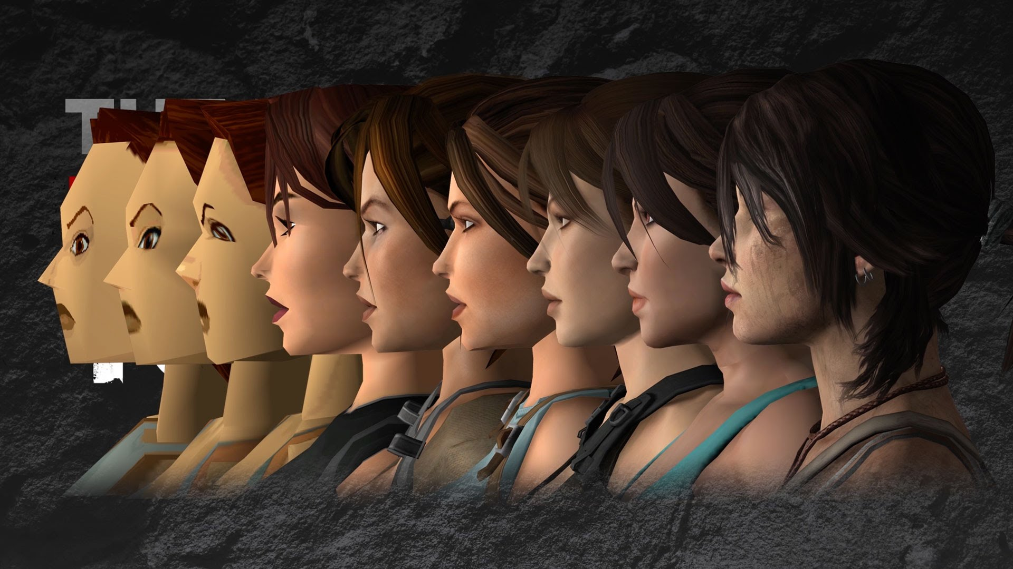
Figure 1.1: Example of graphical advancement of Lara Croft – from 1996 to 2015 [3]
With the increased expectations from audiences of ever-increasing detail in the games that they play, it has resulted in a ballooning of budgets for games, despite the cost of games increasing slowly, and indeed being lower than ever [4].
This huge increase in size of budget has resulted in a number of changes to development in the industry, many of which are out of the scope of this report. The area that is focused on is the cost of asset creation, and techniques that can be used to reduce this without hindering or compromising on player experience – or by taking things a step further, designing systems that are better than the traditional methods employed.

Personal Interest
My motivation for pursuing this particular project was due to my desire to start a career in the video game industry after graduating from university. My final year project stood out as the perfect opportunity to further expand the skills and expertise learnt from my course at Loughborough and my Industrial Placement in a direction that would increase my potential for a career in that particular sector of software development.

Technical Research

Existing Approaches
For a short-term Undergraduate project, a suitable level of scope and ambition had to be arrived at given the resources, time, and technical knowledge that is available. As such, existing approaches to solving the production cost were examined, and the most suitable for the project were focused upon.
- Deliberate low-fidelity stylistic choices
While the appeal of photo-realism lies in the desire to replicate the real world and speaks for itself, many companies have found that a conscious approach to focus on style and aesthetics instead, things that do not rely on fidelity. Taking cues from media like cartoons – the results are often strong in vision and age gracefully – avoiding the pitfall where chasing photo-realism causes older games to age quickly as technology shows its shortcomings not many years later while specific style can be enduring and age significantly slower.
The challenge with this is that strong aesthetics and theme require a stronger level of ability in the artistic and creative departments during concept phases of development, contrasting with photo-realism which simply progresses rote techniques to chase the real world, a far more objectively measurable goal.
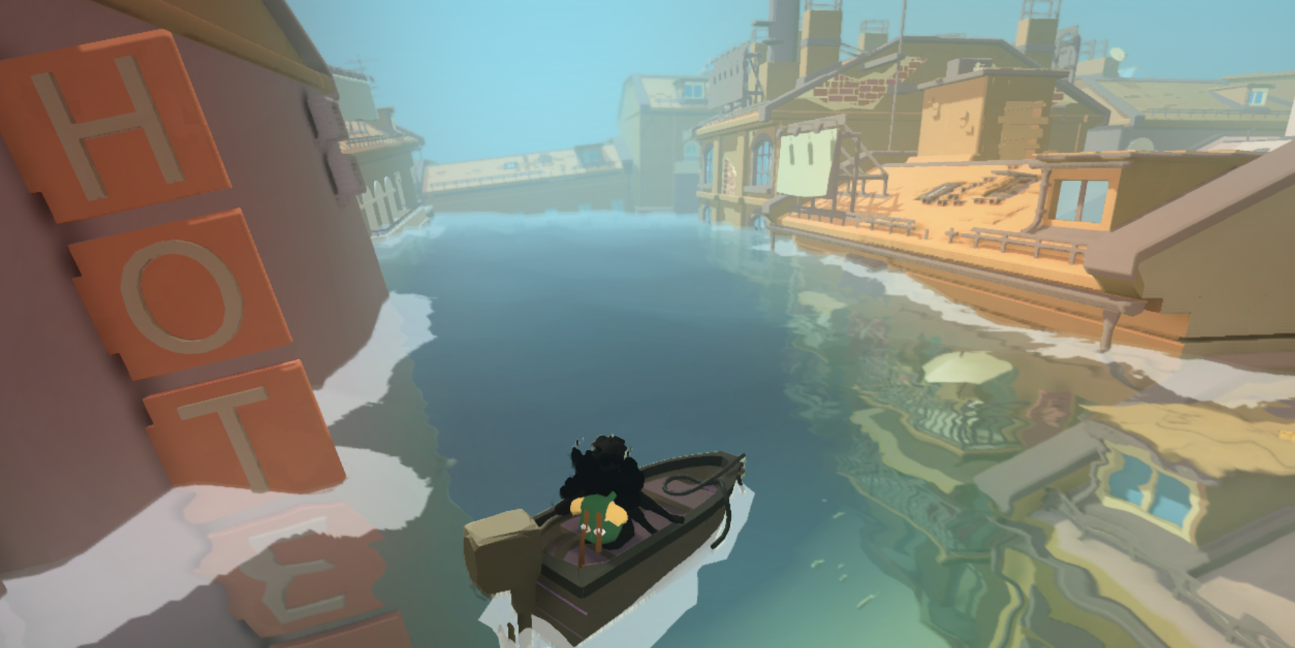
Figure 1.2: Modern game employing low-poly aesthetic [5]
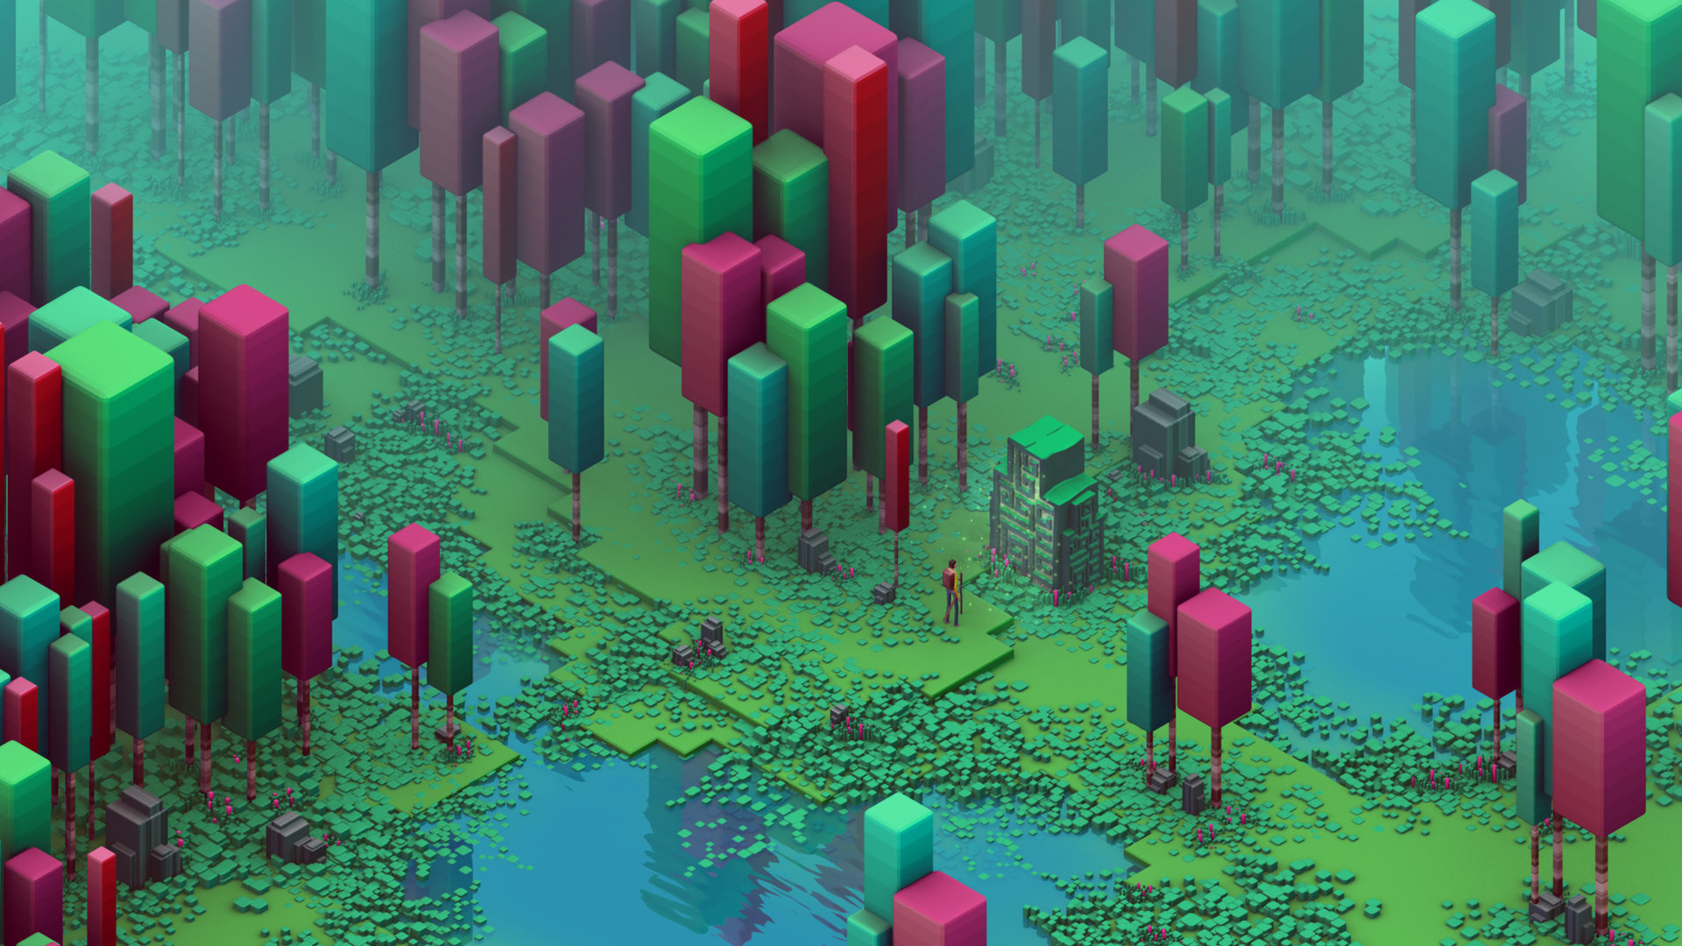
Figure 1.3: Another low-poly video game [6]

This project used a low-fidelity, ‘low-poly’ graphical design to allow a consistent and satisfactory look for the game, without taking away significant amounts of time that were instead spent on the more technically-orientated challenges.
- Content recycling
Many projects, particularly ones with limited time-frames for development re-use assets and content to reduce the sheer size of the amount of content needed for the project. While effective when done tastefully and correctly, it is very easy to create the problem where such recycling is easily perceived by the player, and acts as a disincentive towards continued play and completion of the game. Repetition and the feeling of 'filler' content is hard if not impossible to avoid, as well as it being immersion-breaking, or highly limiting in scope relevant to the original project vision. Recent large commercial projects to use this were criticised for the use of content recycling in lieu of more development time [7]. For this reason, content recycling was ruled out for this project.
Journalists
- User-generated content and sandbox systems
Many games, most famously the recent cultural smash-hit Minecraft succeed in unloading the burden of content creation by instead providing the players with the tools and abilities to create their own experience. This is particularly powerful as it helps engage and involve the player in a way that resonates as respect in the player, as well as appealing to a wide variety of people, as each particular niche of player can choose to go in their own direction.
The downside to this approach is that it is only suitable to games that work as sandboxes – games with tightly controlled pacing, or strong narratives are at odds with empowering the player creating their own path. While this can work for racing games to critical acclaim [8], the level of resources required to orchestrate such design is well above that which would sensibly fit this project, so it was not used.
- Procedural content
Generating content via algorithm has been done for many years, with some as early as 1980 [9], but mostly in a select few genres. As the fidelity of games increased, many of these genres dropped using the mechanic in favour of developer-created content. The strength of procedurally generated content is that it engages the player by making every play-through different, keeping things fresh and exciting; while at the same time hopefully lowering the burden on the design and art teams of the development team.
There are issues however – it is not suited to all genres of game, particularly those where tight control over the experience is needed for narrative reasons, similarly to the sandbox issues noted above. It is also possible that coding the functionality to drive this technique could take longer than simply creating it the usual way if the design is not carefully considered beforehand. Technical complexity aside, underfed design utilising procedural content could result in an underwhelming final product – where either the game isn't fun or the randomness does little to differentiate the gameplay moment to moment and between each play-through.
In researching this technique, it became apparent that the technique has had a revival in recent years [10], with many commercial offerings in several genres appearing on store-fronts. With a racing game in mind, I only managed to find a single example of using procedural content – which was created for a PhD thesis exploring the use of procedural content in video games[11].
This project, known as ‘Permutation Racer’, exhibited several of the strengths that helped prove that procedural content was possible in a racing game, the implementation of the generation ended up being more about variety in the ‘voxel’ (3D pixel) terrain, and placing obstacles in the way of the player. For this project, the approach was much more about the track itself being wholly guided by procedural functions and so a different implementation would be needed, though Permutation Racer clearly showed the potential possible, and so this was used as one of the main focuses of the project.
- Consciously lowered budget (and subsequent lower price to customer)
Some companies – particularly independent ones, have decided to reject the chase towards realism, and instead place focus on simply achieving what they can with a much more limited budget, and having a lower-priced product to reflect the lower production costs. After all, fidelity doesn't equate to successful gameplay. The drawback to this approach is that it goes against the cultural expectation of ever-progressing realism and fidelity, and portions of players will dismiss or ignore such smaller games, instead focusing on the big blockbusters – a not dissimilar situation to non-mainstream film, television and music.
Given that this project was for an undergraduate project, this was a given point for the project from the start, where the advantages can be utilised while the non-commercial nature of the project allowed it to avoid any of the downsides of this approach.

Dynamic Difficulty
One of the challenges in using procedurally generated content is how to control it. Overly controlled and it stops feeling random, but unchecked it will be at best not enjoyable, and at worst simply unplayable. This led to the idea of the procedural generation being tied to the particular player at hand, and so led to the concept of a dynamic difficulty manager. As a technique, dynamic difficulty has gained popularity in the last few years, with titles such as Oblivion, Left 4 Dead and even Mario Kart using it.
Issues arise with dynamic difficulty where the difficulty is either over-tailored to the point of unenjoyable, or clashes with the tone and reality of the situation. For example in Oblivion, all enemies in the game are scaled directly against the level of the hero, ensuring that they never encounter a challenge in the large open world that will be unforgivingly hard to beat. However, the problem was that the opposite also occurred – as the player increased in power, none of the minor enemies ever felt easily beatable or insignificant, where even the sewer rats would continue to be scaled up for the most powerful players. This lead to players sensing a lack of progress, and soon unofficial modifications were created to alter the behaviour, although not completely remove it [12].
In Mario Kart, players at the back are given better power-ups than those at the front, but later titles were criticised for this handicap ‘rubber-banding’ too much, removing too much skill and thus player satisfaction from the game [13].
To avoid these problems, difficulty can be split into two parts. The first part is a linear difficulty increase where as the player gets further in a session, the game will get harder, regardless of the player input, much like many traditional games. The second part is a dynamic difficulty, which influences the relative difficulty depending on the player. In this way, beginners and strong players can be challenged similarly, without any adverse influence on the other.

Game Engine
To realise the vision of a racing game with dynamic difficulty and procedural content, it became apparent that creating such a game from scratch would be futile given the constraints of the project, and so the intent was to instead learn and leverage existing technology as used in the games industry – this is also more realistic to the situation developers find themselves in at the beginning of projects, and so the success of the experimentation done in this project carries more practical weight because of this.
For this reason, this project was built using the Unreal Engine – the industry standard used by more companies all over the world than any other, with more than three hundred shipped commercial titles for just one version [14]. Recently the engine's pipeline has been tailored to allow for smaller projects with less experienced and fewer people involved, but also allowing powerful leverage of the functionality present. This allowed the project to focus on the specifics of the procedural generation with regards to track generation and difficulty, rather than spending all of the time on interesting but irrelevant challenges of things like physics and rendering.

Project Description
The initial description of the project was the following abstract:
“This project will explore the possibilities and potential behind procedurally generated video game content in the form of a futuristic racing game, whereby the racing track will be generated on the fly, giving each successive play of the game a fresh challenge and experience. This idea stems from the very real problem that modern video game companies face when financing the creation of games with production costs sky rocketing and fidelity ever-increasing.
By creating a nuanced set of analysis tools and algorithms that assess how the player is doing, the tracks can not only be generated automatically, but also be partially tailored to the current player in question, creating a personalised game experience by being matched to the ability of the player. The two main challenges of this project are uniting the influence of the algorithm and level generation with an engaging racing game, and the technical challenge of the game engine used for the project.”
Which led to the finalised project statement:
“To explore the relationship between procedural content generation and dynamic difficulty in video games.”

Aims and Objectives
The initial project description was distilled down into the following core requirements for the project:
- The game will be a futuristic racing game with abstract and minimal visuals
- The game will focus on single-player gameplay goals
- The track will be procedurally generated chunk by chunk
- The performance of the player will be analysed to influence the track shape and difficulty
The visuals took inspiration from low-polygon art, which focuses on basic, simple shapes making up a stylised simplistic look – allowing for a quicker content pipeline which is one of the techniques for reducing production costs as elaborated on in the research section if this report at 1.3. It also gave more time to focus on the main interest of the procedural content and dynamic difficulty.
While multi-player is common in racing games, the scope of track creation and difficulty adjustment made for enough of a project without involving networking or player interaction which are another layer of complexity better suited to a longer or subsequent project.
As the track is generated while the game is played, it is created in chunks, using basis splines to control the transform of each turn and straight of the track. This also allows for an 'infinite track' style of mode.
Player performance is core to the gameplay – measuring this is from a mixture of variables, but includes completion of each chunk against a timer, how often the player is colliding with the track sides, and if the player is having to brake often. All of these factors have to be considered together to provide a single judgement on the overall skill of the player.

Requirements
Expanding on the aims and objectives, the following requirements reflect the necessary accomplishments needed for the project to be a success in the goals that it set out to achieve.

Driving
- The driving style of the player vehicle is a test of fast reaction (as opposed to a realistic simulation)
- The player is highly discouraged from making any contact with the wall by incurring strong speed reductions upon collision
- Due to the procedural nature of the track, the player is given ample warning of the obstacles ahead via camera placement and distance.

Visuals
- A simple visual design is used to present a cohesive but informative presentation to the player
- Visual cues are used to inform the player of important information in order to use as few UI and text elements as possible. This is known as diagetic UI design.
  - Player speed is shown by the behaviour of the camera and the visual look of the vehicle
  - Turning is instantaneous, reflecting the fast pacing of the driving, and visually emphasised
  - Likewise, slowdowns are shown by camera distortion and movement
  - Track progress is shown via colour and other effects on top of a standard UI counter

Track Generation
- The track shape is created in chunks using B-Splines, with which a 3D mesh is deformed around to create the actual track to drive inside.
- The track features several types of turns and curves, reflecting a real life driving track:
  - straights
  - turns
  - ‘sharp’ turns
  - s-bends
- Each of the types of track pieces apart from the straights are modified by the difficulty, either making them sharper (harder) or straighter (easier).

Difficulty
- The difficulty gradually increases over time, regardless of player performance
- After the first four gates (checkpoints), the player’s performance measure is used to formulate a score which influences whether new pieces of the track are easier or harder
- Several statistics are tracked for measuring performance, then stored for each interval between checkpoint gates:
  - number of collisions
  - number of times brakes used
  - top speed
  - average speed
  - average time left on gate

As a whole, these requirements form the core tenants of the project which were used as guidelines upon which the design phase was directed by, with each part of the design having to refer back to one or more of these requirements.

Design
This section outlines the designs of the project visual, gameplay and algorithmic generation, with justification and explanations for each of the decisions that were made to arrive at the each part of the final design.

Visual Identity
The overall project visual style used is known as ‘low-poly’ in graphics and visual design. Low-poly is characterised by its 3D meshes that are deliberately using a low number of polygons and zero textures, instead opting to use flat, matte colours. The result is a striking and distinct look achieved with less resources and time needed for creation. This made it a sensible choice for the project, where visuals were not the focus of it, but are still important in the sense that they are needed for the game to be functional and engaging.
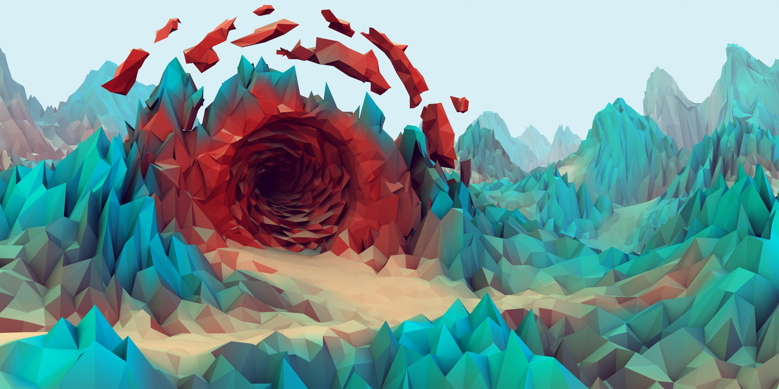
Figure 3.1: Typical low-poly graphics [15]

Vehicle

Vehicle Look
For the design of the player vehicle, inspiration was taken from past and present racing games with a futuristic aesthetic. The key feature of the vehicle is that it hovers, rather than having realistic wheel-based motion. As well as keeping to this style, this difference helps players suspend their disbelief at the feel and handling of the vehicle compared to any real-world vehicle handling they might intuitively expect.
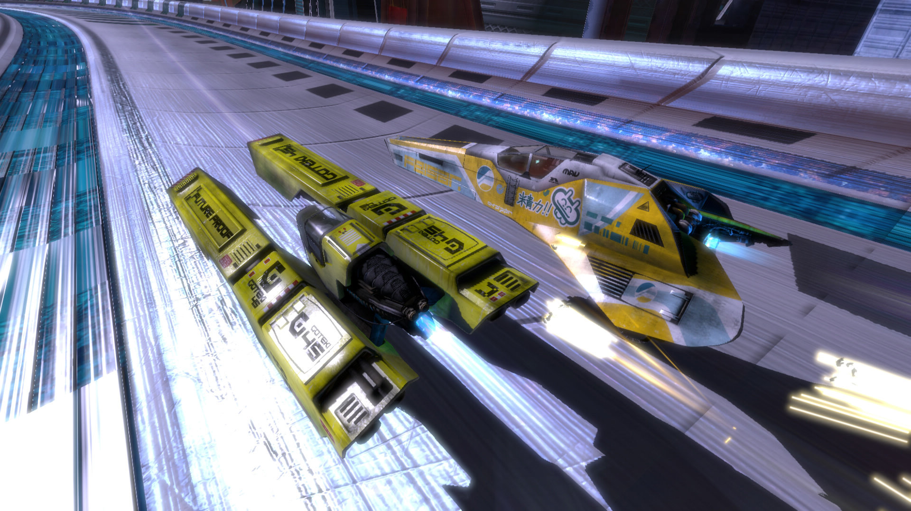
Figure 3.2: Screenshot of Wipeout HD for the Playstation 3 [16]
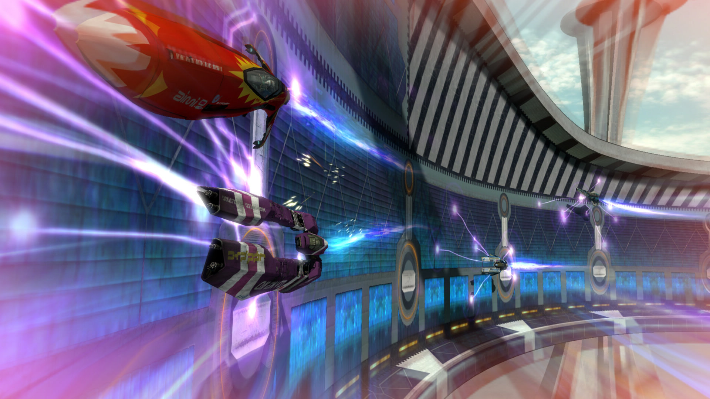
Figure 3.3: More Wipeout HD vehicles [16]

Several designs were drawn, with the intention of offering the player a choice of vehicle with different handling characteristics, perhaps unlocked by progression of the game. However the focus to begin with was a single vehicle, which ended up being the only vehicle implemented with difficulty management and track generation taking priority.
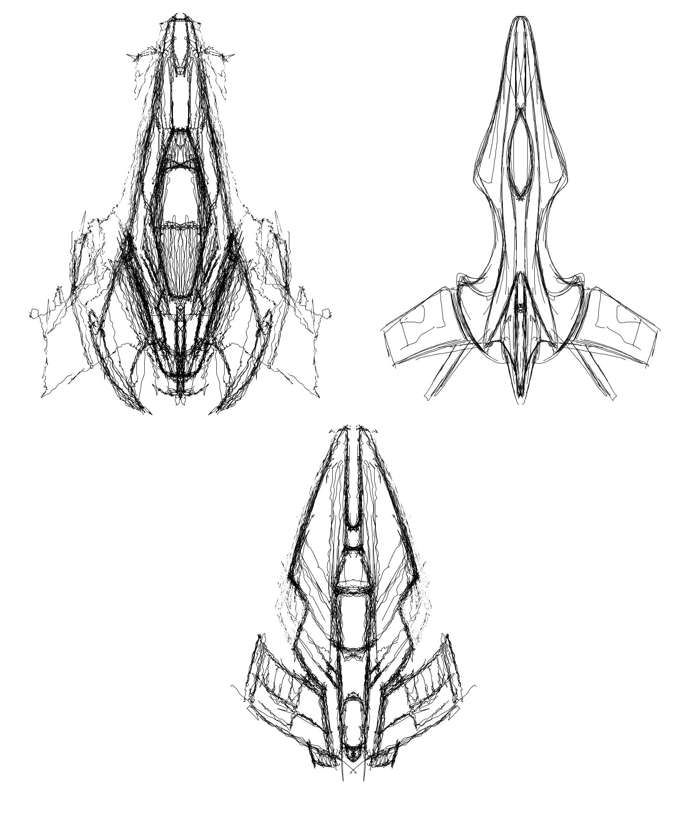
Figure 3.4: Three vehicle styles explored
A single design from figure 3.4 was chosen, upon which the side view in figure 3.5 was designed.
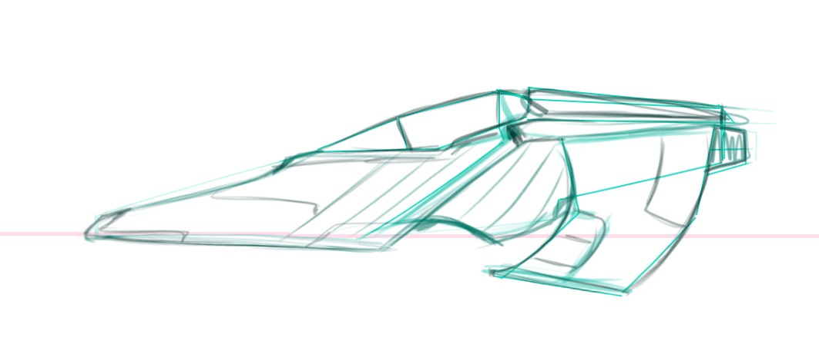
Figure 3.5: Side view of chosen vehicle design

Vehicle Handling
The vehicle is fast moving – faster than any conventional real-life car. The reason for choosing this style of driving is that it demands concentration and fast reactions from the player – these provide ideal conditions to test the track generation and difficulty adjustment as if they are unbalanced it will be extra apparent. The vehicle closely responds to player input, and uses a mixture of visual cues to make it clear to them.
By increasing the distance of the player camera from the vehicle when going faster, and decreasing it when going slower, camera distance acts as an obvious and immediate indication to the player of their current speed.
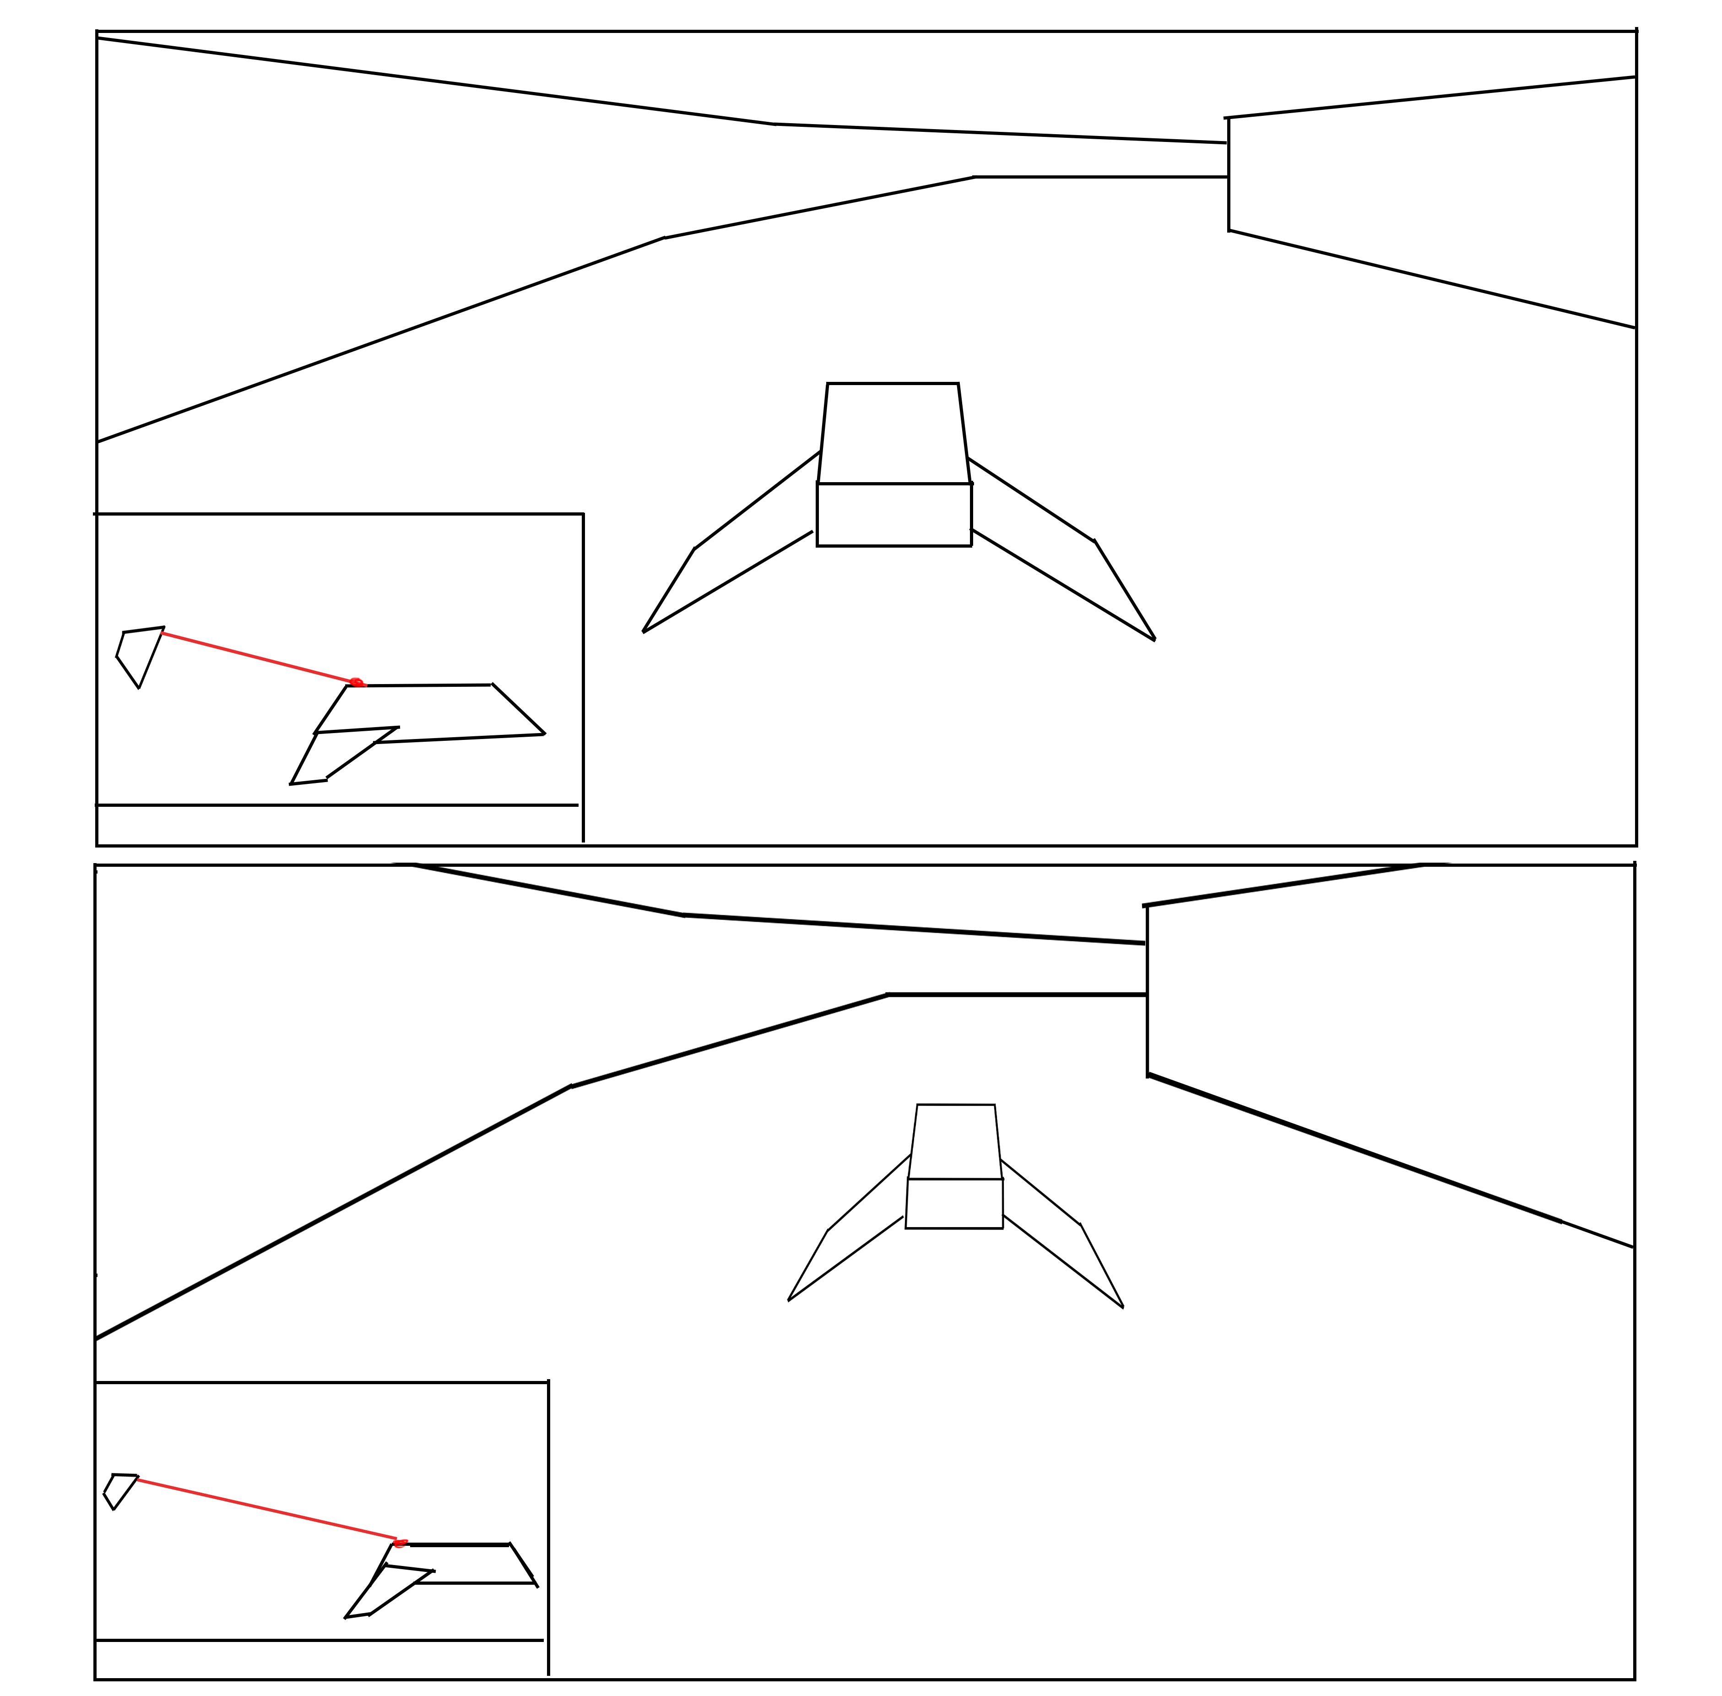
Figure 3.6: Camera distance showing the player their speed
Vehicle trails are also dynamic, based upon the current speed. By enlarging and shifting the colour of the trail, as well as increasing the number of trails as the vehicle speed is increased, it gives the player further visual information of their speed.
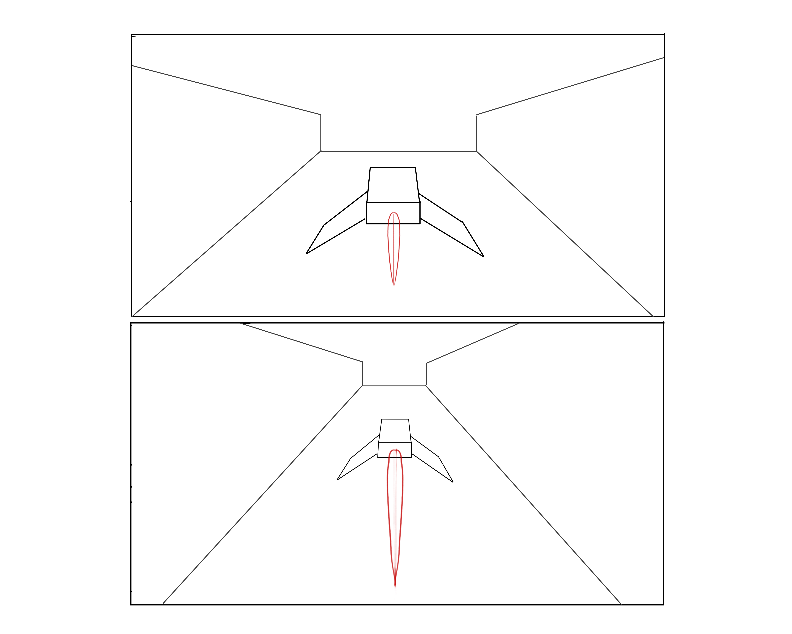
Figure 3.7: Thruster size and length based on speed
Vehicle rotation is used to help show the player the degree at which they are turning, as at higher speed is it important to turn and take corners in a more precise fashion.
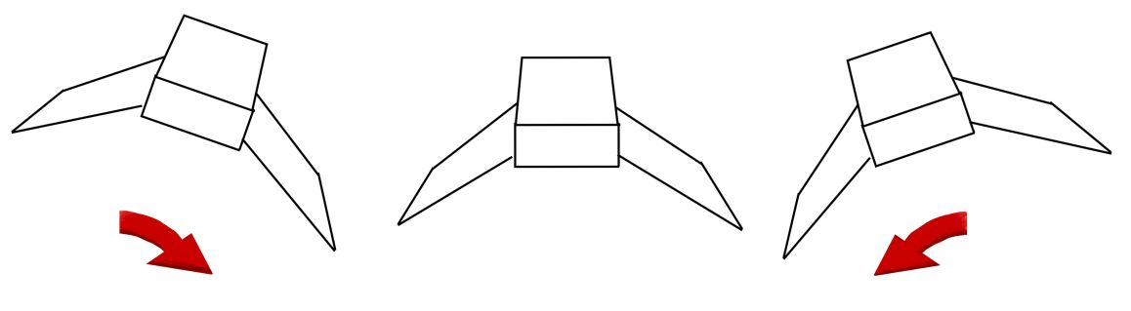
Figure 3.8: vehicle roll with player turning input
Actual numbers of the current speed will be shown in the corner of the screen, large enough to be read at a glance so the player doesn’t have to take their gaze off the track ahead, but small enough that it doesn’t cover too much of the graphical world behind it.

Track

Track Piece Shapes
The main track pieces are the following:
- S-bend
- Curve
- Tight curve
- Straight
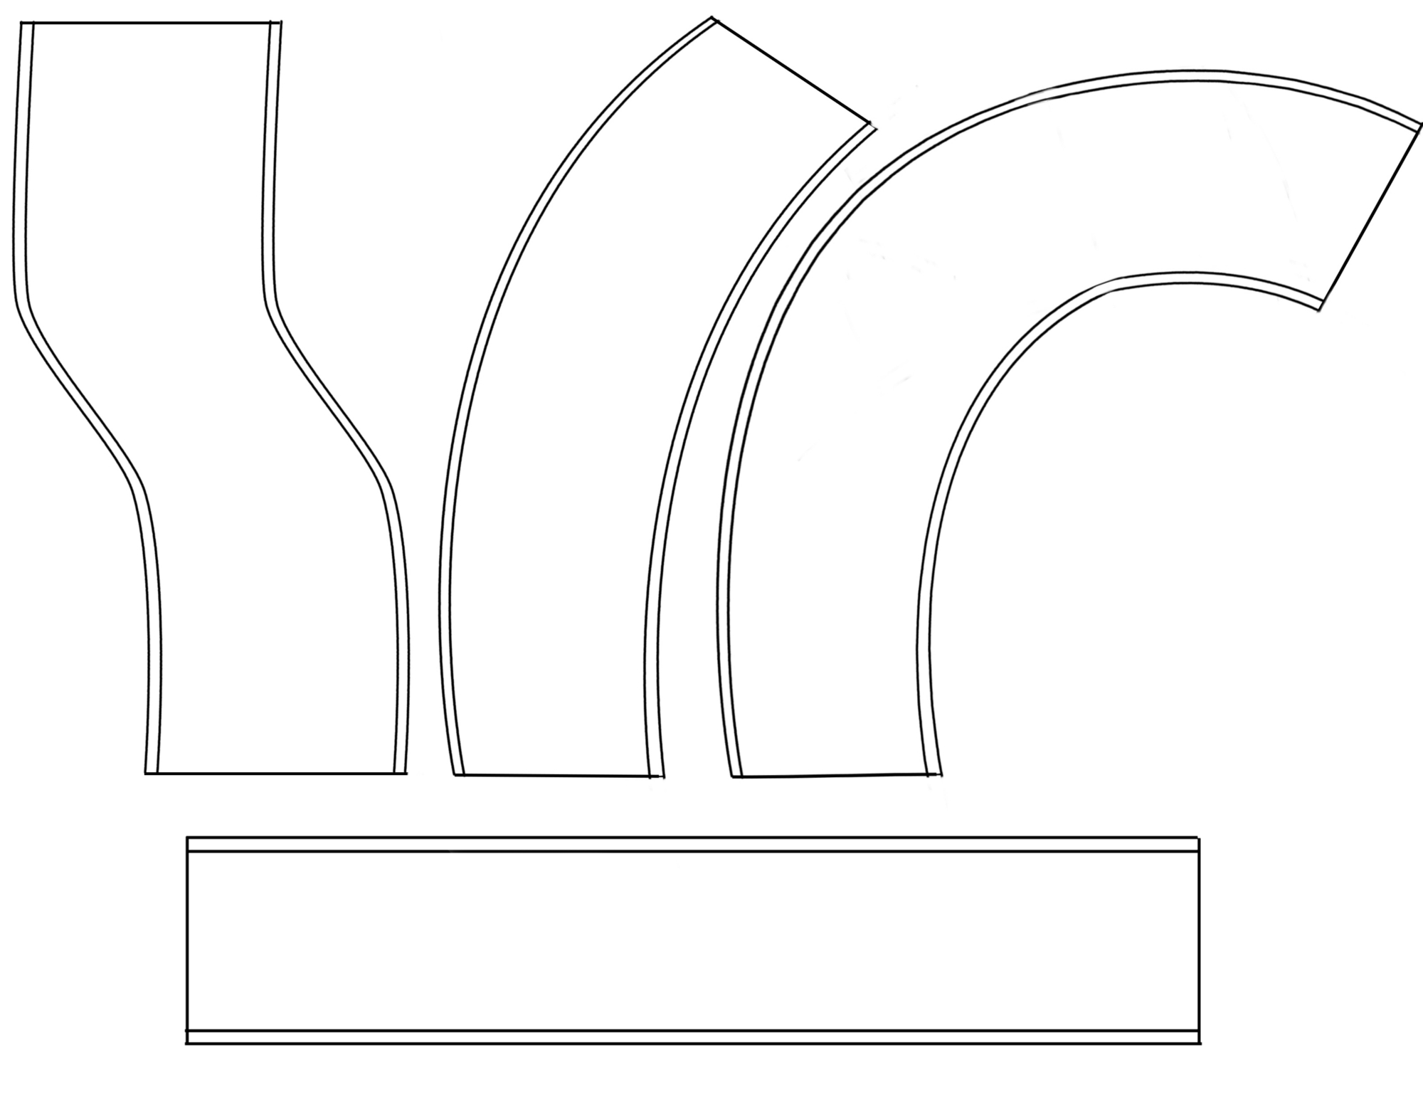
Figure 3.9: Track piece shapes
These pieces are then malleable depending on the current difficulty:

Figure 3.10: Curve piece at several difficulties
These pieces were chosen to reflect the variety and obstacles that are common in both other racing games and real life – by having a variety of twists and turns, the player has to be paying attention all of the time due to the combination of each piece being chosen semi-randomly and the high speed of the vehicle. While more fantastical shapes could have been used, this would have pushed the focus of the player onto the discovery and how to manage/react to these unfamiliar shapes, which was not the intention of the project.

Track Piece Look
The track pieces use a small single slice of a track which provides sides for collision, and a floor for the ‘hover’ of the vehicle to look correct and function.

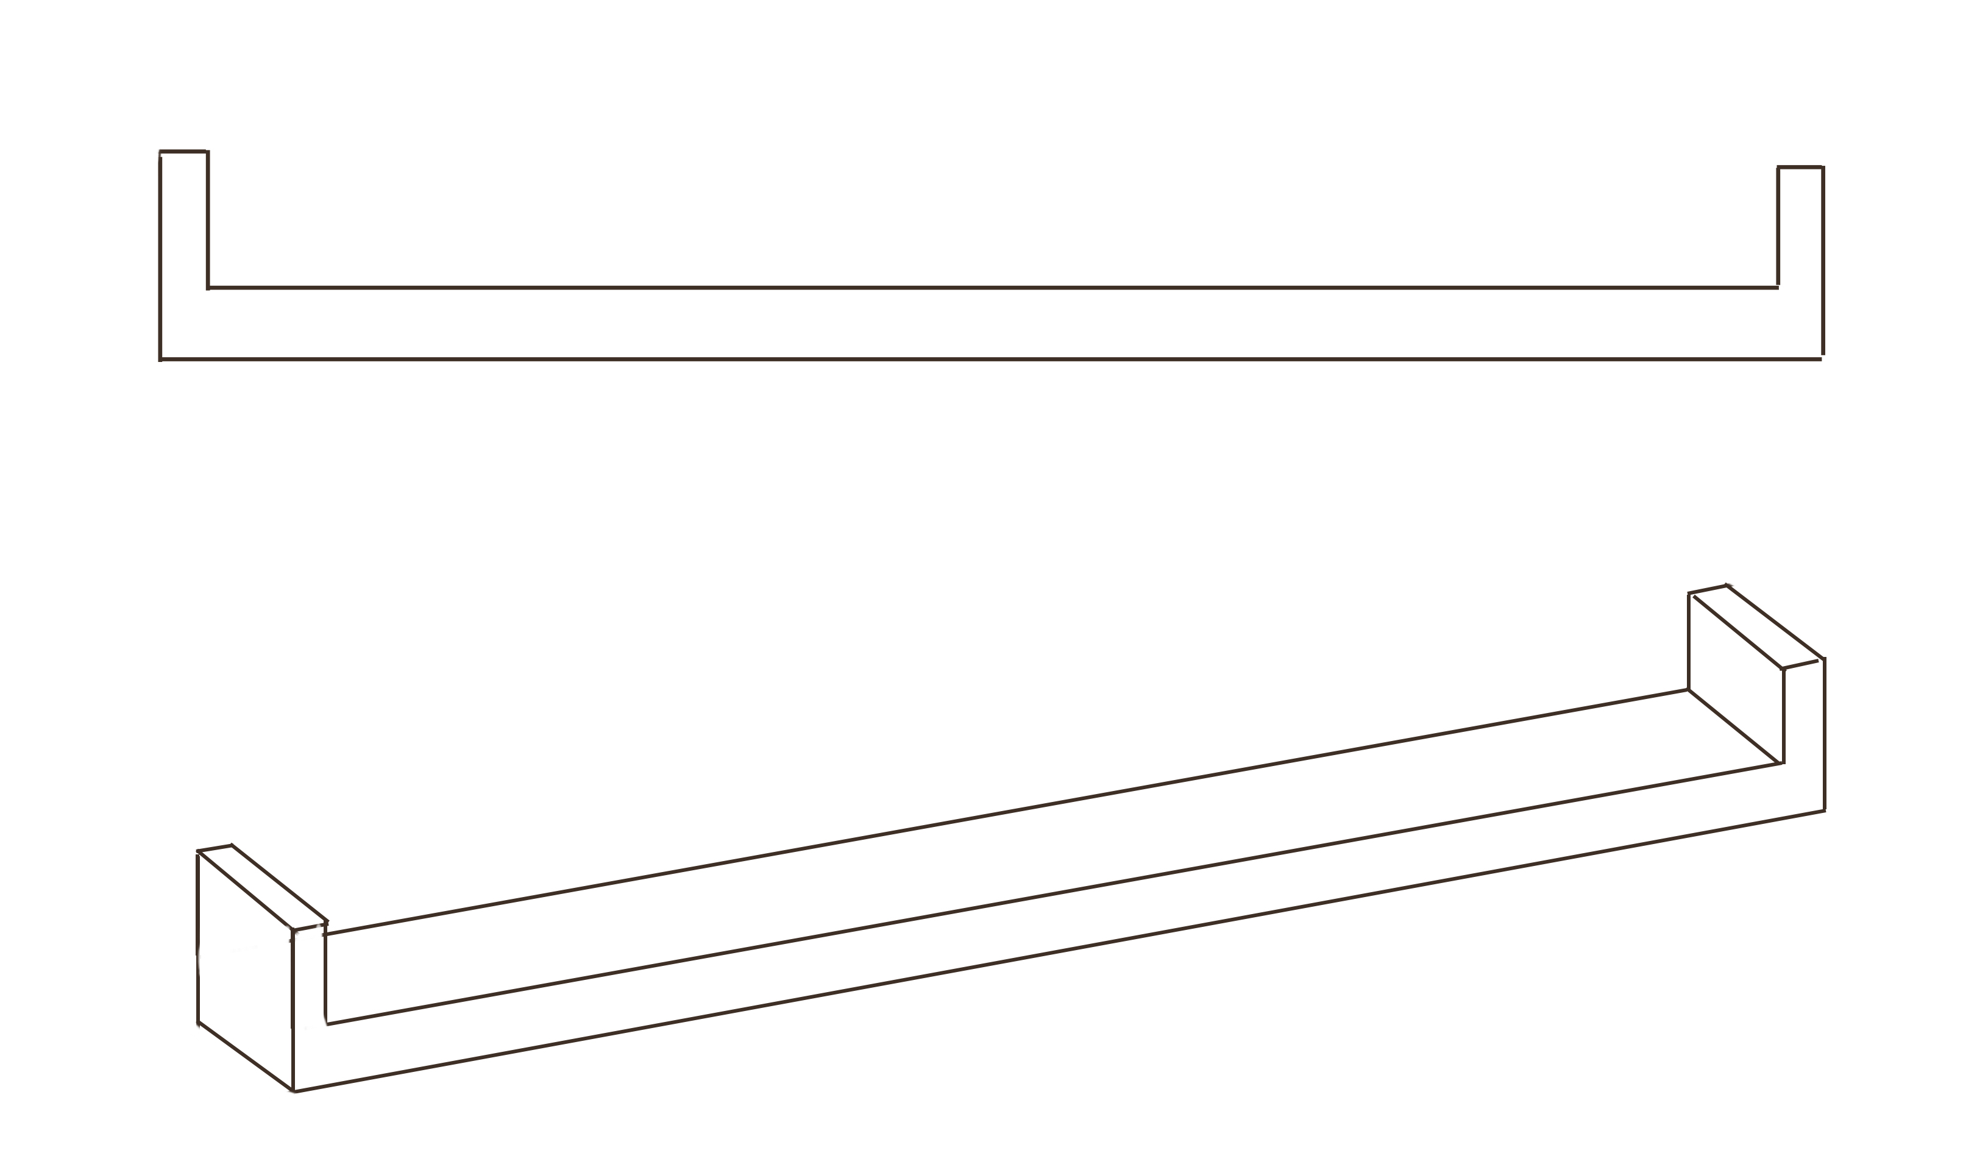
Figure 3.11: Single piece of track
This piece is then stretched and warped to follow the curvature of the spline, creating the track mesh the player sees.
In keeping with the other elements of the game, the track has a low-poly, texture-less appearance of a solid colour. This gives it a smooth appearance that stands out despite it being easy to implement, meaning less time and resources are spent on it compared to the more important tasks of difficulty and track generation. The clear design also makes the track easily readable for the player, allowing them to focus on navigation of the obstacle rather than spending part of their reaction time on first identifying what is in front of them in the game.

Track Piece Construction
To allow for fine-grained control over the track pieces adjustment, B-splines are used to create the track shape down to a precise level. For each pair of connecting points of the spline curve, an instance of the track 3D mesh is created, providing a smooth and seamless join between each chunk of track.
This removed a lot of effort over the manual construction of track pieces in 3D modelling software, lessening the time and effort from the artist portion of the game, part of the core focus and justification of the project.

Difficulty Manager
The difficulty manager is in charge of monitoring player performance and adjusting future track pieces generated in response to how well the player is doing.
Several statistics are tracked and stored upon passing a checkpoint gate. An average is taken for the last few checkpoints to gauge player performance, with a weight assigned to each of the tracked statistics in relation to their importance.
Tracking too far back would include data no longer relevant as the chunks generated further back would have been too different for it to be helpful for the current situation, while not tracking enough of the previous chunks would over-fit the recent data, which would swing the difficulty back and forth from small mistakes and successes.

The measures of player performance are as follows:
  - number of collisions
  - number of times brakes are used
  - top speed
  - average speed
  - average time left on gates
Collisions are an obvious and strong indicator of the player struggling to navigate the track, and so they have the strongest weighting on the final difficulty adjustment.
The player using the brakes often shows lesser errors than collisions – they have realised their mistake and so much correct it by braking. It is important to note that the track can be traversed without use of the brakes, and so stronger players are able to use them less. Players are expected to use the brakes more and more as the difficulty goes up, as there is less allowance for error and the tighter turns are less forgiving.
The top speed of the vehicle shows whether the player is confident in driving through the track – the best players should be hitting the higher speeds. Because the top speed is relatively easy to reach, this has a smaller weighting than the other indicators, mostly addressing the small cases of absolute beginners who will be unsure of using accelerate as confidently.
Average speed shows how much rubber-banding the player does while driving – taking into account collisions, brake usage and acceleration. It is useful to assess players who manage to avoid collisions but have to compromise by braking or not accelerating as strongly.
The average time left on gates is a good way of seeing whether the player is passing each checkpoint with ease, or is struggling to cross the line before running out of time and game over occurring. All of the other factors play into this one – collisions will lose the player significant chunks of time, particularly front ones. Playing too safe and driving slowly will also lead them to struggle to reach the checkpoints, particularly as the track gets harder.
These statistics are not directly shown to the player though the overall ability score is, and the resulting harder or easier new generated chunks will be obvious. This will show a clear level of progression to the player and indicate how they are managing with the difficulty over time, giving them a sense of accomplishment as they engage with the difficulty algorithm while trying to improve against it.

Together as a whole, this design section outlines the methodology and justification for which the project followed in both a player-facing sense and how the requirements would be fulfilled, abstract of the actual technical implementation.

Implementation
This section explains and shows the techniques used to implement the design choices made for the project, directly in code written, the engine functionality used, and graphics created that resulted in the final project that the use plays.

Engine
Unreal Engine 4, the game engine used for the project, provides a variety of tools allowing creators to focus on their actual project rather than implementing core, basic functionality that every game needs. It is a general, multi-purpose, multi-platform engine that tries to facilitate any and every sort of game development paradigm, with the counter-point that it stays neutral in not offering any more scope or help for specific genres or game types.
Unreal Engine 4 is written in C++ with the entire source-code available to developers, is cross-platform for both development and deployment to the user. With version 4, it became free to use either non-commercially (whether academic or personal use), or commercially with a license stipulation of a 5% cut of profits made after the first $3,000. Having been the industry standard third-party engine for many years, this was quite an unusual move when released two years ago [17], and represents a shift in focus for independent, small developers having access to the same tools as the largest video game companies in the country.
With access to the source code and six months of prior experience, Unreal was the most sensible way to achieve the goals of the project while still suiting the scope and limitations of the resources available, as writing a game from scratch would not have been possible given the expertise and time required. Having access to the source code also gives concrete transparency when depending on outside tools for the project, as reasons for behaviour and bug fixes could be found as they arose throughout development. No other engine existed with the tools, flexibility and documentation/community that Unreal has, prior experience with the tool also meant that I was confident in some aspects of the engine already, and made me confident that it was appropriate for the task.
Unreal also offers unmatched prototyping power with its ‘Blueprints’ – a node-based visual programming paradigm that allows for rapid development which can talk back and forth with any C++ code written, and matches functionality almost identically. Allowing developers to work in more abstract logic terms, this allowed the project to progress at a rapid pace without the slow-down of traditional programming language foibles and syntactical issues. After functionality was in place, the blueprint code was then methodically converted into C++ for efficiency, performance and extra flexibility. Doing this also gave me the generalised C++ coding experience that I hoped to gain from the project. Despite the additional cost of resources in having to convert blueprint to C++ by hand, it still worked out quicker than working purely in C++ from the start.
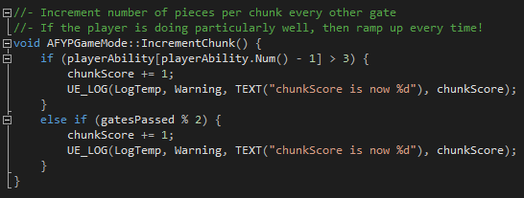
Figure 4.1: Simple C++ function in project code
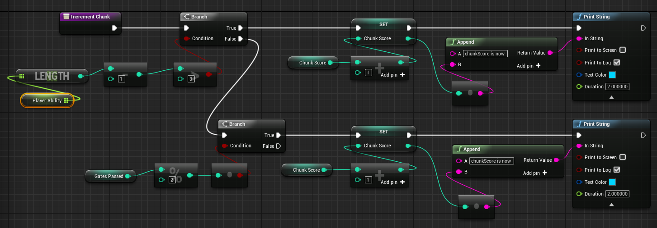
Figure 4.2: The same function as 4.1 but in blueprint visual scripting
Figures 4.1 and 4.2 show a simple comparison of an identical function in blueprint and C++, illustrating the appearance of blueprint and how it implements the same logic as the C++.
While it is totally feasible to produce and complete a game purely in blueprint which I have done in the past, the lesser performance (some operations are up to 200x faster in C++), and the inevitable spaghetti-like nature of Blueprint as seen in figure 4.2 means that it is not normally advised. By using the C++ engine API, it also gave me necessary, valuable coding experience that is applicable in settings outside of Unreal Engine which is likely to occur, and so adhering to strictly blueprint would be a wasted opportunity.
Unreal provides a basic framework of classes for which all games made in it will adhere to, where there is an instance of the gamemode which controls the rules of game, with a player controller per person that is controlling a player ‘pawn’, taking input from a controller or keyboard/mouse.
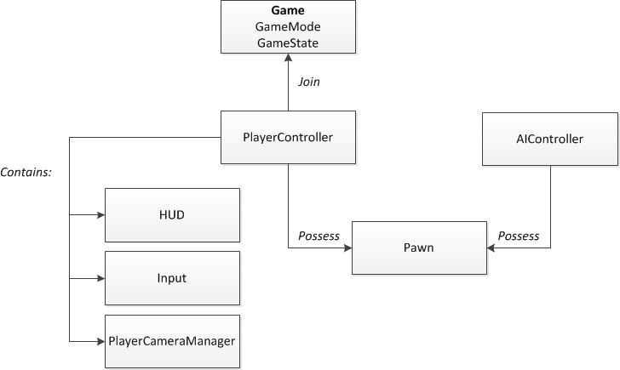
Figure 4.3: Framework of a generic Unreal project
In the context of specifically this project, Unreal was used for the following:
- rendering
- tick functionality (constant stepped time)
- physics simulation
- particle framework
- input handling
- transformation, rotation and scale of meshes
- B-spline support
- UI display
It is important to note that what the engine offers for these is the capability to use these features, and not much more. It is up to the developer using the engine to learn how to correctly utilise and control them, where in some cases this results in almost as much work as creating them. A simple analogy would be that the game engine acts as a box of simple Lego blocks that provides the potential to build things, but requires the ingenuity and design to actually create something out of the Lego, rather than a model kit with instructions. With no specific, ‘ready-made’ blocks, the creator has to work out how to piece them together to create the larger design and implementation, rather than simply sticking several parts together like with the model kit.
To give the example of the physics capabilities, it provides a physics simulation insofar as the developer can tick a box to enable gravity and physics on any static mesh, but then it is up to them to manipulate and control physics with the correct mathematics and forces (torque, impulses, drag, etc.) to do what they intend to the mesh. In the case of this project, physics was employed to create the simulation of the player controlling the vehicle. With no shortcuts or facilitation for vehicle control in the engine, it was up to myself to decide on how to simulate driving physics, which is detailed in section 4.2.
Another example is the particle framework. Particle systems in video games are a technique that uses a large number of small 2D images to simulate the appearance of any graphics that are not solid, for example smoke or fire. In this project, the player vehicle uses particles to simulate the thrusters on the back of it. The engine provides the ability to manipulate particles in many ways including acceleration, colour and size, either at spawn or over time, but the engine has no pre-made resources or work done for the developer in creating their own particles. They must fully understand and invent how the desired effect behaves in order to create it, which is often quite elaborate and complicated for even simple effects. Figure 4.4 shows the scale of particle creation for just one of the three visual effects on the player vehicle.
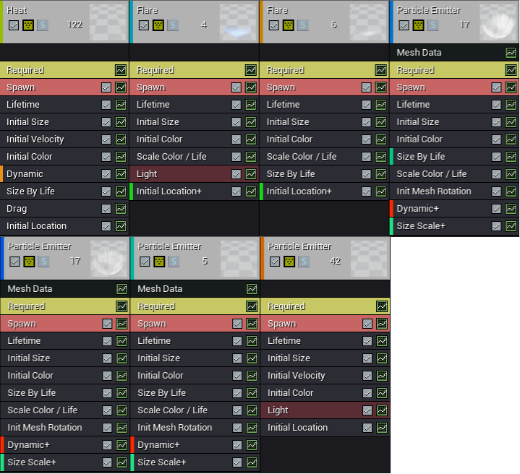
Figure 4.4: 1/3 of the particle structure for the vehicle exhaust
The engine also supports the use of B-splines for any purpose, to the point where the engine understand the concept of a spline consisting of a sequence of connect points and tangents. In the case of this project, the track pieces that utilise B-splines had to add a lot of extra functionality around this to allow for the concept of the mesh following the spline points.
The engine provides access to hardware values from player input, for example detecting when the player has pressed or released a button.
Rendering in Unreal uses a physically based renderer (PBR), where the look of the game environment is controlled by influencing the light bouncing around the scene via mesh materials, and each surface giving off specular and diffuse reflections. These are controlled by material properties such as colour, metallic, and roughness. With the goal of trying to follow the physical behaviour of real light as close as possible, it is down to the developer to control and influence the final result by changing the meshes and textures that are inside the level.

Vehicle Movement
The design of the player vehicle explicitly emphasises fast speed, tight controlling and a futuristic setting which reflected in it floating above the ground rather than using wheels.
There were two clear ways to handle the implementation of the vehicle, and so work was done to create prototypes of both types, after which the superior was chosen after examination.
- Full implementing a ‘real’ hovering physics simulation
- A purely visual hover

Full hover Implementation
To simulate proper hover on the vehicle, four line traces are emitted from the base of the vehicle to the floor, all independent of each other.
Each of the line traces return the distance from the floor, upon which a decision is made:

- If the line trace is short (i.e. the vehicle is too close to the floor) then exert a physical force on that corner upwards
- If the line trace is long (i.e. the vehicle is too high up from the ground), then stop applying the force.
With each of the four corners acting independently combined with a rapid line trace, this results in hover-like functionality which will respond to height change and have the strong visual appearance that the project design called for.
The main disadvantage of this approach was that it proved harder to implement controls that felt like they satisfied the criteria in the design – fast movement necessitates a ‘tighter’ feeling where increased speeds exacerbate less responsive controls. Because the vehicle is truly hovering, any physics impulses impacted by acceleration or steering would also influence the four hover points, and as a result creating a strong control system proved difficult.
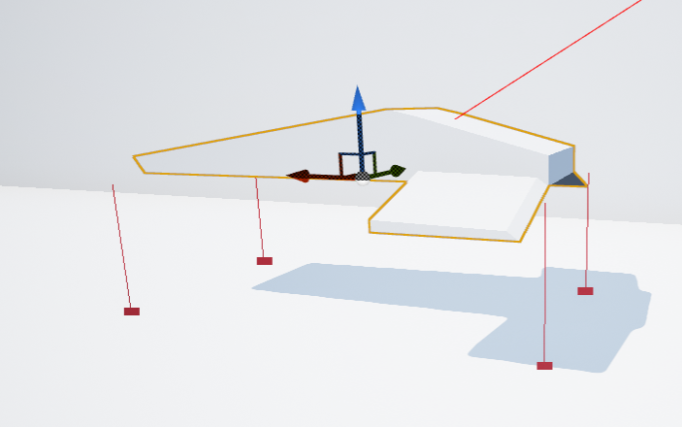
Figure 4.5: Red visualisation of line-traces from corners

Visual hover Implementation
The second approach was to do away with actual hover simulation – while it looks compelling and can offer good handling of height changes, not doing so will simplify the complexity of the vehicle handling. Instead, gravity can be turned off on the vehicle, and it can stay at a constant height above the ground, thus any acceleration and turning contends only with themselves, rather than the hover physics as well.
The main disadvantage of this method is that more sophisticated terrain shapes are not handled – the most obvious example being if the track had tilt.
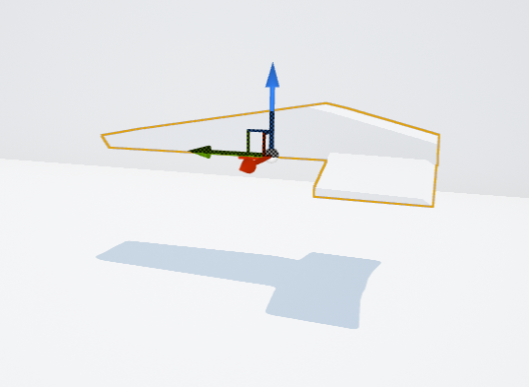
Figure 4.6: Visual hover
As shown in figure 4.6, the simpler implementation simply ‘hovers’ by lack of a downward force applied to it, and so stays at a constant height from the floor mesh below it.
Due to the focus of this project being mostly on procedural track generation and dynamic difficulty, the decision was made to use the simpler, less flexible vehicle handling. This allowed the quickest progress to be made on the handling of the vehicle, leaving more project time to focus on the track generation and difficulty, with minimal compromise on the minute-to-minute gameplay of the project.
The vehicle movement is handled by treating movement and vehicle rotation as seperate pieces of logic. During each engine tick, the player input is polled for any input, and if the player is trying to move, then the relevant turning or accelerating functions are run (and can run simultaneously). While the vehicle technically has no friction as it hovers, turning friction is artificially added and taken into account of movement to ensure the vehicle has tight handling and doesn’t feel like the player is driving on ice. All forces applied are in kgf/cm², and need applying continuously over each physics tick.
Figure 4.7: Acceleration logic
Shown in figure 4.7 is the acceleration loop that is executed every tick of the game while any movement input is detected. Friction is simulated by adding an additional force depending on the current rotation of the vehicle. The final force is applied to the mesh to propel it forwards or backwards, depending on the player input.
The player input can be either 0/1 if using a keyboard, or a float value that allows for finer control over movement if a controller with analogue triggers is used.
Turning the vehicle is done by applying torque on the vehicle mesh. When a turning keypress or controller stick movement is detected, a z-vector is created using the input value and the torque is applied using this, introducing yaw movement. The input value is also used to determine visual roll on the mesh to further inform the player of their turning. The logic for this is shown in figure 4.8.
Figure 4.8: Turning and rotation loop

Collision is handled by treating the front and sides differently. Frontal collisions are abrupt and immediately reduce player speed to effectively nothing. Side impacts will instead gradually lower the speed of the vehicle by a percentage of their current speed, incrementing this for every second that the player spends touching the side of the track.

Vehicle Design
Using the design drawings, a 3D mesh was created of the player vehicle.
Collision boxes were then added on the sides and front to differentiate between types of collision.
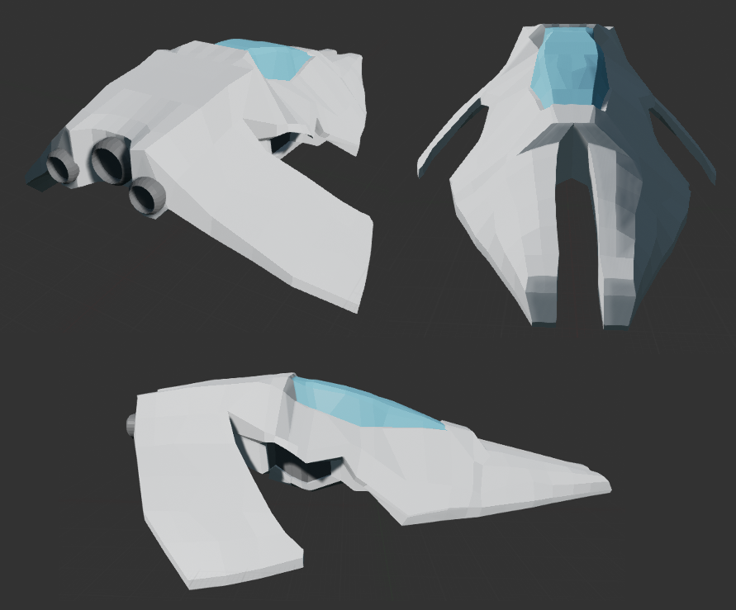
Figure 4.9: Finished vehicle model
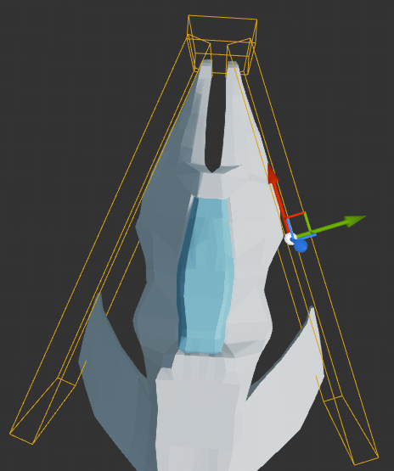
Figure 4.10: Left, right and front collision boxes
After the 3D model was complete, the particle effects helping inform the player of their speed were added, as well as the variable camera distance.
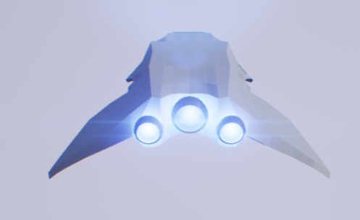
Figure 4.11: Idle thruster particles
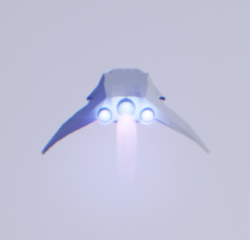
Figure 4.12: Low speeds show the central thruster engaged
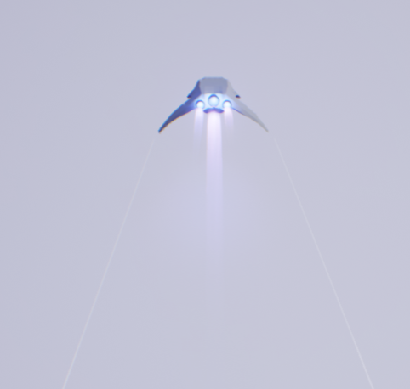
Figure 4.13: At high speeds with contrails, three thrusters
Figures 4.12 and 4.13 show how the vehicle distance changes with speed. Figure 4.12 shows a short camera distance as well as as only one engine engaged, while figure 4.13 shows the vehicle appears much further away from the player, and has both the contrails and all three engines engaged.
Visual distortion was added on the screen when the player collides with the sides, emphasising that they should try to avoid doing so much, and to increase player immersion. The strength of the visual distortion is directly mapped to how strong the collision impact is, giving the player further diagetic information on the severity of the speed lost due to the collision. The effect used is a combination of screen-shake and chromatic aberration [18].

Track

Track Look
The track piece that was modelled as a thin slice is unmarked and simple to allow it to be seamlessly wrapped around the splines of the track. The spartan design meant that it took up almost no resources to create which was better spent on the actual track shape creation algorithm.
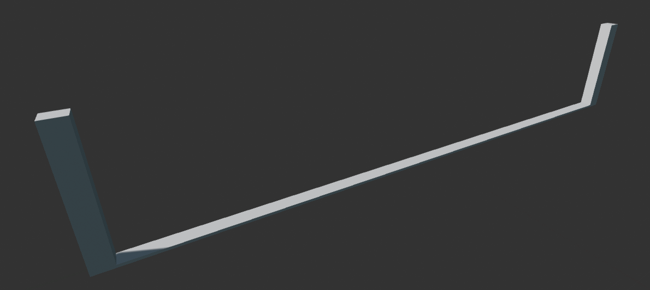
Figure 4.14: A single piece of track
Once shaped around the track spline points, the track pieces created are simple looking that attach together perfectly for the player to drive round.
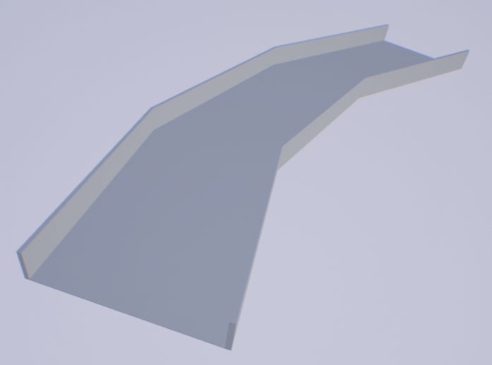
Figure 4.16: Track piece as it will look to the player
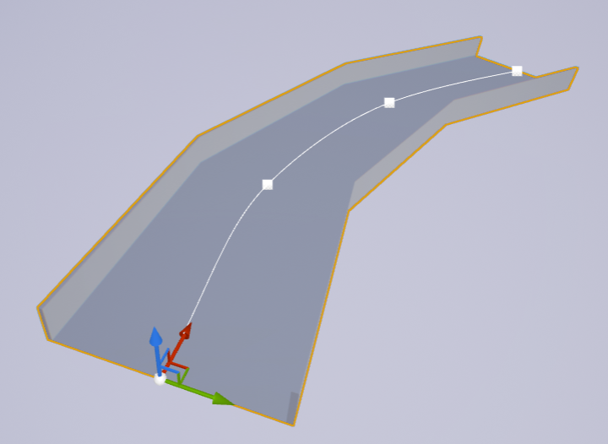
Figure 4.15: Track piece in game editor (showing spline)

Figure 4.15 shows the spline curve that has been created in the game world, and then how the single short track mesh is used to create the full piece of track. The player will only see the track mesh however, like in figure 4.16.
One of the features introduced in the project after player feedback was giving the player a better sense of progression and reinforced accomplishment once a gate is reached, particularly when the player is trying to outdo their previous record.
Where previously the track pieces were a plain grey consistently for the whole game, this features adds dynamic colour shifting of the racing track around the player. Every time the player reaches a checkpoint gate, the entire track changes colour in a quick fade from the position of the camera outwards in the world. This is achieved by using ‘dynamic materials’ where the colour of the material applied to all of the track pieces is controllable via an RGB vector variable. When the player passes through the gate, a new colour is generated and expands outwards from the player camera as a gradient, resulting in a clear indicator of progress and variety of environment for the player.
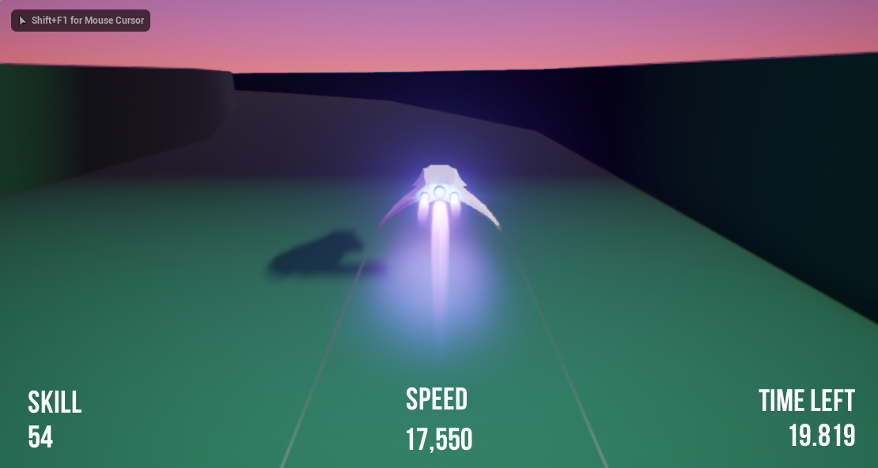
Figure 4.17: Fade effect from starting grey to a blue-green
While hard to capture and convey in a still image as in figure 4.17, the effect is far more impressive to the player in motion. The basis for this effect was inspired by a similar idea in the Wipeout series during the ‘Zone’ mode.

Track Generation
Track generation is handled as a whole by three classes of increasing generalisation. The game world then has a single instance of the top-level class, upon which the entire track is generated and managed.
- AFYPSpline
  - This handles a single track piece
  - The piece is made up of a spline and the matching mesh that follows it
  - The particular spline chosen depends on both randomness and the current player performance
- AFYPChunk
  - A chunk is made up of several AFYPSpline objects and a checkpoint gate object
  - The number of spline pieces in this chunk depends on the progress and skill of the player
- AFYPChunkManager
  - This is the top-level manager that controls the creation and destruction of the multiple AFYPChunks
  - It keeps track of which chunk is active for the time limit the player has to reach the next checkpoint gate
  - Only two chunks are in the world at once for maximum performance
To create the pieces of track in AFYPSpline, there are two main stages.
First the spline itself is chosen and created. The spline point locations and tangents for all of the pieces are all stored in a struct. Each of the types of track piece have a weighting of difficulty – where for example a straight is easy while an s-bend is considered difficult. As well as this, each track piece has 9 variations of itself at different levels, ranging from straighter and easier to tighter and harder, providing the variety required for an interesting track for the player to drive along. The track piece that is chosen depends on the current assessment of the player skill. The stored locations and tangents of the chosen piece are used to create the B-spline of the piece.
Secondly, the actual track mesh that the players see is created. To do this, each adjoining spline point has to be mapped to a mesh, with the effect of doing all of them creating the smooth, singular appearance shown in figure 4.14. Iterating over each of the points of the spline, an instance of the simple track mesh is created, with its starting and ending location and tangent exactly matching that of each pair of joining spline points.
Figure 4.18: Creating a track piece

Difficulty Management
The difficulty management is responsible for tracking how well the player has been doing, and adjusts the challenge of the track in the immediate generation of track pieces to come.
As in the design specification of the project, five points of data are tracked on the player in real-time – number of collisions, number of times the brakes are used, top speed, average speed, and average time left on checkpoint gates. Upon the player passing through a checkpoint gate, the current values of these statistics are stored as an entry in an array that is tracking how the player does from chunk to chunk of the track.
If the player has passed through at least 4 gates, the player skill is immediately updated. It will take into account the average of the last 4 checkpoints worth of data, with each data point given an appropriate weighting based upon their importance, and then a final player ability value is arrived at. The player ability only starts being assessed after passing four gates because players are less consistent and not ‘warmed up’ at the start, regardless of skill. This will be used by the Chunk Manager to decide on how to generate the next chunk – the number of pieces that the chunk comprises of and the difficulty variant of each piece to use. With nine points of variation for each type, the end result is a substantial gap in challenge between a chunk generated for a beginner compared to that of one generated for an expert.
To avoid a stalemate of difficulty balance, where the player is kept at a constant point where they are comfortable, the difficulty of the game generally trends harder – thus ensuring that the player is continuously challenged, and the player gains a sense of accomplishment and improvement as they reach further and further past more checkpoint gates. The trend of difficulty is accelerated for strong players, to avoid the climb of difficulty being too slow. This was a problem that was encountered in the research of similar games, where a frustratingly large duration of time is spent playing is breezing through the easy stages just to reach the challenging portion.
Figure 4.19: Difficulty logic upon passing through a checkpoint gate

Testing
Testing the game was broken down into four key areas of importance – driving, track generation, difficulty management, and general testing. Perhaps the most essential part of adequately testing the game was having a variety of skill levels amongst players, which allowed for assessment of the difficulty adjustment which in turn affects the track generation, whether it is being easier on a less experienced player, or particularly punishing on a strong racing game enthusiast.
Testing this project proved to be somewhat unconventional in comparison to traditional software projects, because the focus of whether the game was functioning correctly or not depended on whether it reacted correctly to the player, and what the player thought of the systems that the game promised. If the goal of testing was to verify that the functionality matched that which the requirements and objectives set out to reach, it was the players response to the game which was the actual qualifying answer of whether it was fulfilled or not, because the premise of the game succeeding requires the player to be satisfied.
This made testing both easy and hard – easy because it largely eschews traditional requirements for elements like data inputs that require validation and edge case testing, but hard because the solution to fixing a disappointed response from the player is not always obvious or straight forward in what exactly is wrong or not working.

Driving
Through the development of the project, vehicle handling was adjusted and tweaked, particularly nearer the start where two entirely different approaches were considered. Because vehicle handling is nuanced and bespoke in implementation, a lot of trial and error as well as guidance from feedback from testers through the project timespan had to be used to accomplish the implementation that the final version of the project used.
In additional to this, a somewhat novel approach was used to make small adjustments to the handling while the game was live and running. A MIDI controller was attached to the developer environment, and by associating each variable in the vehicle handling code to a dial, it was possible to make small granular adjustments to the handling while the game was running. By doing this, it was possible to get immediate feedback and manipulation of the vehicle handling to a degree where traditional back-and-forth adjustment would be lacking.
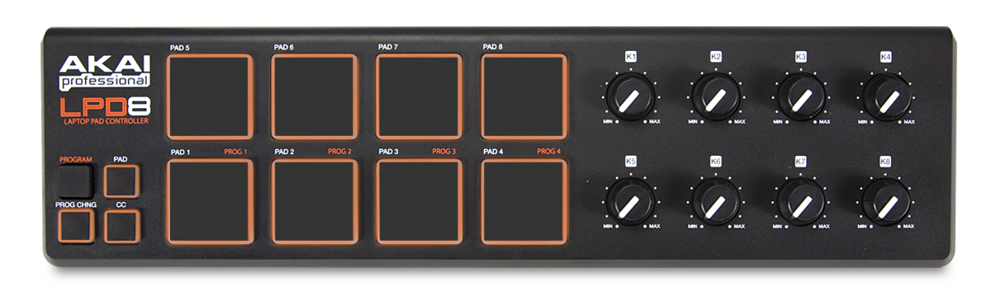
Figure 5.1: MIDI controller used for live variable adjustment
With each pass of the vehicle handling, the variables that controlled how the vehicle felt under player control were revised and improved based on player feedback.
Table 5.1: Vehicle handling values
Handling Iteration | Linear Damping | Angular Damping | Acceleration | ‘Friction’
1 | 0.2 | 2.3 | 10000 | no
2 | 0.2 | 3.0 | 20000 | no
3 | 0.8 | 5.0 | 20000 | yes

On the first iteration, the players found the vehicle too ‘icy’ and that it controlled too slowly. For the second iteration, the top speed was doubled after re-examining video of commercially available games in the vein of the project [19]. Angular damping was increased to try reduce the feeling of drifting while, to some success but not eliminating it entirely. After this second iteration, each tester was specifically asked about their thoughts on the drift to further identify exactly how it was not satisfactory. For the final version of the handling, amendments were made in response to the tester feedback.
Firstly, damping on linear and angular movement was increased significantly more to further lower the amount of drifting that the vehicle experienced.
Secondly, artificial friction was added to the vehicle, despite technically hovering above the ground. For every acceleration made by the player, an opposing force was applied to the vehicle using the sideways direction of the mesh. This dramatically helped reduce the drifting further, to the point where players experienced far greater satisfaction taking sharp turns and bends. The knock-on result of this was the skill-ceiling of players improved, as they were now less restricted by the limitations of the control of the vehicle and instead their reaction times.
To allow for flexibility of player preference and the practicalities of equipment available to players, both keyboard and controllers were supported and tested for controlling the vehicle. The main advantage given by the controller is that the game supports continuous values for turning, accelerating and braking, while the keyboard can only have the discrete values of ‘pressed’ or ‘not pressed’. This gives a greater degree of finesse while using the controller, but due to how many players on the target platform do not have controllers, testing was done on both inputs to ensure a playable experience using both.
Although the track only uses a small section which is repeatedly used for all variants that can be generated, collision behaviour had to be tested on each piece due to it being generated at runtime and so there being some possibility for odd behaviour. The player should be able to expect identical behaviour in collision regardless of the pieces chosen, where greater speeds before the collision will result in a larger impact upon the immediate ability to drive the vehicle, particularly frontal collisions.

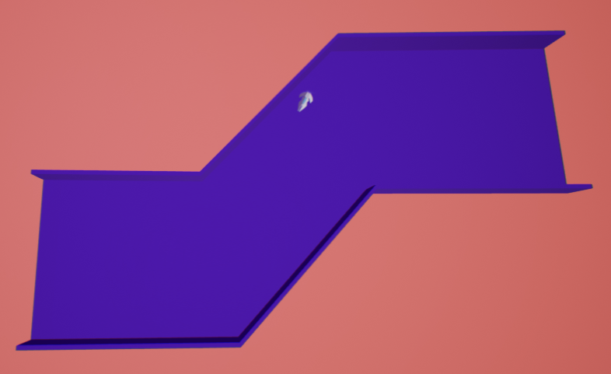
Figure 5.2: Individual piece being collision tested
The player can simultaneously press multiple inputs – where the behaviour of all combinations should behave as expected. If the player presses both accelerate and brake at the same time, then the vehicle will either stall if both are evenly pressed or if they are at different values in the case of using the triggers on a controller, then the input with the higher value will be prioritised at a reduced effect relative to the amount the lower input has been pressed.

Track Generation
Track generation advanced throughout the project, as more variables were introduced that would influence it. The most important factor to test first was whether the track always connected together correctly, giving the player a continuously navigable obstacle to drive around.
Because the track generation algorithm uses the location and tangent of the final splint point of the latest piece of track as the location and tangent for the next generated piece, this ensures that the two pieces will be perfectly lined up where they join. To test that this was the case, each of the nine sets of variations of the track pieces were tested in turn to ensure they connected properly and had the right shape.
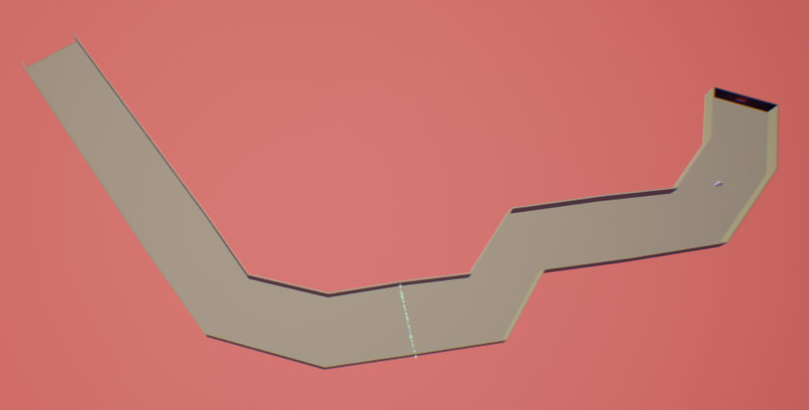
Figure 5.3: Piece variations being checked from above for joining issues
Once the difficulty adjustment functionality was included, further testing had to be carried out that ensured that as each chunk of the track was created, it adhered to the correct variants of track pieces that were appropriate for the current ability of the player. This was tested by manually setting the player ability level then generating a new chunk for each of the player ability levels.

Figure 5.4: Comparison of a chunk of ability 2.5 (top) and ability 4 (bottom) – the ability 4 chunk has noticeably tighter turns and is longer
As a single session of the game progresses, the number of pieces in a single chunk gradually increases, at an increased pace for skilled players. The rate of this linear increasing difficulty was tested at various levels to see how players coped with it – too slow and the player would not be challenged enough, while too fast would not give the players time to acclimatise and gain a steady level of performance, resulting in their score being inconsistent and random.
Table 5.2 The rate of linear difficulty increase during track generation
Iteration | When to increase pieces | Highly skilled accelerated
1 | 1 | no
2 | 2 | no
3 | 2 | yes

In the first iteration of track generation, players found that the increase was too fast, and they were quickly unable to keep up with the rising difficulty, creating a situation where beginners were overwhelmed and experts were not able to warm up.
In the second iteration the rate of increased was halved, which created a much slower pace of increasing difficulty, noticeable by players but sensible to the point where they would try to match it. The issue with this however, was that the skilled players found this increase too slow, but to increase it would be going backwards towards the first iteration, with a compromise where neither beginner nor expert was properly catered to.
In the final iteration, an expert modifier was added – if players were scoring over 3/5 on their ability measurement, then the increase would double, effectively using the approach of the first iteration, but only in the case of when the player is doing exceptionally well.
As the player passes a checkpoint and the new piece of track is spawned, the oldest piece of the track should be destroyed as well. For performance reasons the track will have no more than two pieces at once, resulting in the deletion of the oldest piece being quite close behind the player. This needs to be tested to ensure that the player is not interfered with during this object destruction, nor that it deletes pieces too early – exposing the player to being outside the track.
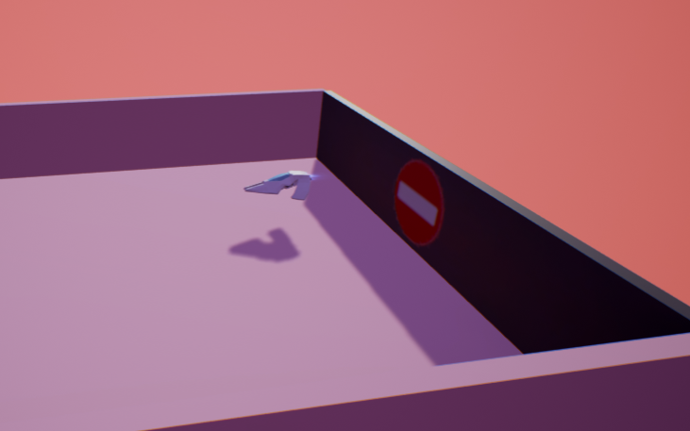
Figure 5.5: previous chunk destroyed once player has passed through the checkpoint
Because each of the track pieces is open at both ends to be joined to the next and previous pieces of track, this results in the beginning of the track being open, and would allow the player to turn around and drive out of the track bounds into the general expanse of the game world. To prevent the player from doing this, an additional mesh is attached to the start of the track to act as a back stop. As the oldest piece of the track is deleted upon passing a checkpoint, this stop mesh must also be instantly moved forwards to now block of the new oldest piece of track, without passing through the player or otherwise interfering. It also needs to perfectly line up with every variant of track pieces to ensure the player cannot somehow escape around it.
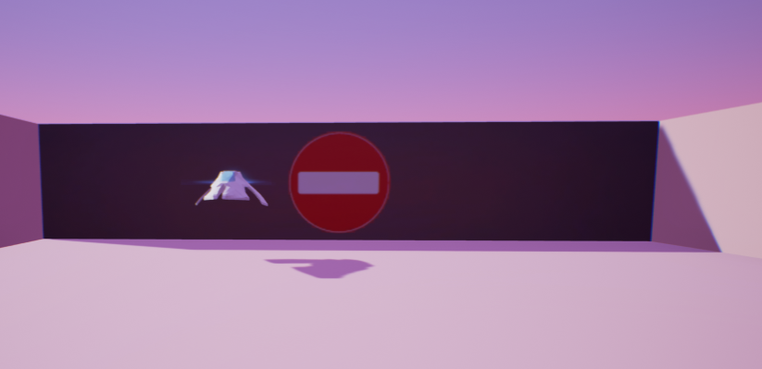
Figure 5.6: Back-piece lined up with the track behind the player

Difficulty Management
Players are informed completely transparently that the difficulty of the game is modified and adjusted to suit them as it is one of the key fundamental focuses on the project. As a result of this, the resulting impression in their feedback was important to judge whether the dynamic difficulty was a success from the point of view from the player. Beginners needed to feel that they were led into the game gentler than a regular driving game fan, while experts wanted to feel properly challenged to the limits of their abilities and reactions. Players needed to feel that their improvement in familiarisation and skill with the game was reflected in the game responding by increasing the difficulty, but also ensuring that if they are struggling that it will slow down this rate to stop them from abruptly failing.
For each of the data points gathered on player performance, these needed to be correct and valid, else they would negatively impact the accuracy and subsequent influence it would have on track generation. The importance of each of the types of data collected were adjusted to reflect the importance and accuracy that each played in best representing how skilled the player is.
Table 5.3 Weighting for each of the statistics
Iteration | Average Speed | Top Speed | # of Collisions | # of Brakes Used | Average Time Left
1 | 0.25 | 0.25 | 2.5 | 0.5 | 1.5
2 | 0.5 | 0.25 | 2.5 | 0.25 | 1.5
3 | 0.25 | 0.25 | 2 | 0.5 | 2

In the first iteration, the average speed was not taken into account enough, and so was raised in the second iteration. The number of brakes used was over-represented, as many players were simply not using the brakes at all. However, for the final iteration, some changes were reverted. The average speed was reduced back to the value it originally had, as the weighting of average time left proved to be a better indicator, particularly when it is so heavily influenced by average speed. The number of brakes used was reduced, as players were more aware of the utility of the brakes, and by this point the superior handling led to generally faster driving which required more brake usage. Number of collisions was also reduced, as many players managed to not collide by being more careful – this behaviour was better caught with the increase in importance of average time left on the checkpoint gates.
The range measured from beginner to expert for each of the statistics was used to properly map out what was regarded as a good and bad score to get on each of these measurements. These were changed after player testing to better match their abilities to the scale of difficulty in the game. Note that collisions and number of brakes used are both reverse, as these are negative factors on the player ability.
Table 5.4 Range mapping from 0..1 for each of the statistics
Iteration | Average Speed | Top Speed | # of Collisions | # of Brakes Used | Average Time Left
1 | 0 – 9000 | 0 – 10000 | 15 – 0 | 5 – 0 | 75% of timer
2 | 0 – 18000 | 0 – 20000 | 15 – 0 | 10 – 0 | 60% of timer
3 | 0 – 18000 | 0 – 20000 | 15 – 0 | 30 – 0 | 50% of timer

Between the first and second iterations, average speed and top speed were both doubled to reflect the top speed being increased by a factor of double in the second iteration of vehicle handling. Brake usage was made more lenient due to some players clearly driving well despite their regular use of the brakes. The average time left on each checkpoint was also decreased, with 75% proving too difficult and unrealistic to achieve for any but the first few checkpoints. For the final iteration, the allowance of brakes was further increased, as the best player was found to use the brakes often as the difficulty of the pieces of track raised throughout a single play-through. The average time left was decreased to 50% of the timer however, as 60% still proved too hard to achieve for any of the players after the first few gates had been passed, while 50% was the realistic upper limit for players driving perfectly.
As the player skill is based off an average of the past few checkpoint skill scores, this needed to be both reflective of the current skill they are performing at, while not being over-reactionary to any lucky streaks or accidental mishaps that would not be representative of their abilities.

Other Testing
Because the project is quite confined in terms of the user input and potential for variation on what happens from player behaviour, this meant that lots of the usual places of testing did not apply – there is no validation of user input or edge-cases for values that can be adjusted by them.
Guards were used to catch exceptions of operations that could fail – such as getting references to specific objects in the world-space, casting objects to specific classes, or checking arrays for their element sizes.

Difficulties and Accomplishments
This section outlines issues and accomplishments that were experienced through the project, the reason for their occurrence. Often accomplishments were gained in spite of, or due to the difficulties, requiring resourcefulness or inventive decision-making to solve the problems.

Difficulties
In the duration of this project, difficulties were encountered in most areas of the development. Some of these were results of the technical choices made early on the in project, with unforeseen consequences down the line.
Despite being the industry-leading game engine, with hundreds of commercially shipped games and a new version with a strong focus on independent developers or small teams, using Unreal Engine was a cause of many issues through development. The fourth version of the engine – the one used for this project, was still reasonably new in software development terms. The decision to develop it with a more rapid-style release schedule also resulted in complications.
With such a large code base to Unreal Engine and deliberately open-ended functionality to create any sort of game, it is essential to have good API documentation. Unfortunately, perhaps in part due to the infancy of the current version, documentation was often very lacking and resulted in requiring close examination of the engine source code to understand how particular features or functions worked – or worse, trial and error. While it was helpful that Unreal includes its source code which allowed this to be possible (as many licensed engines do not include it without a substantial extra fee), requiring regular examination of it is not conducive of actual developmental progress. Additionally, the documentation that did exist for new developers of the engine often focused on visual programming in the engine with Blueprint, not C++.
The project was initially started in blueprint because it provides a very quick and powerful way to prototype and explore ideas using almost the full power of the engine without being weighed down by full C++ syntax and coding idiosyncrasies. Converting each part of the project from Blueprint to C++ did take a significant portion of time, and while logically it was a step-by-step task, bugs were introduced and problems arose throughout, especially when the C++ side of the engine was almost always more obtuse and awkward to access despite the functionality being closely mirrored by Blueprint.
This was further compounded by large upheavals of the C++ syntax and API that the engine used, particularly during some of the earlier versions of the engine during the beginning of the project. This required refactoring not-insignificant parts the project code which had been working for weeks or months, then suddenly deprecated by the engine developers. While the changes made were improvements, it still resulted in duplicating functionality and having to repeat the learning of engine standards which ended up being lost time that could be spent on other parts of the project.
At times there were unreasonable technical limitations on features the engine had exposed but were underwhelmingly supported, and workarounds had to be used to compensate for this. An example of this was the poor support for runtime generated splines, where I had to write a simple one line patch that reversed some undesirable behaviour in the engine, after spending several days searching and combing the code base for the cause of the behaviour when no resources online resulted in anything.

Accomplishments
Despite the difficulties of using such a large and slightly immature version of the engine, I managed to gain a large number of skills, some as a direct result of this situation. Even though I had made several small games before this project, they were short-term projects and did not have a full software life-cycle, particularly with iterations with player (customer) feedback. Proper planning and design for a large portion of time in the beginning was necessary before starting to delve into coding, and the benefits of this became readily apparent further into the progress of the project. Using proper feature prioritisation, task management, and source control, I learnt a significant amount about project management where previously I had not had the opportunity to do so. Balancing the project alongside the other modules of the academic year and absolute deadlines forced proper feature prioritisation, particularly towards the end of the year. The engine strongly encourages the use of source control, and has deep integration with various solutions which further encouraged good task management and coding practises.
By using all of these, I was able to stick to the schedule of my Gantt chart almost entirely until the final hurdle where a difficulty with spline manipulation delayed the completion of the final piece of difficulty management. Despite this delay procedural content generation and dynamic difficulty was sufficiently explored and completed to the point of showcasing a compelling example of the usage of such techniques.
I have gained a significant amount of experience using a professional, industry level game engine which is used by many of the companies offering graduate jobs that I will be applying for, putting me ahead of many other applicants as a direct result of this project. The experience of both utilising the strengths and being constrained by the limitations of a large code base not directly controlled by myself was an experience in the practical reality of the world outside of small toy coding projects, and required a lot of thinking and understanding that is necessary when interacting with old code out of your control.
With some prior experience using C++, I was nevertheless surprised by the amount of syntactical and structural experience gained from using the language in a much larger project setting rather than smaller projects like that of the programming modules in previous university years. Modern C++ 2011/2014 features, strong memory management and very large pointer usage was all heavily required for the project and I had not used them in such a capacity before.

Recommendations

Driving
With time and experimentation, it would be possible to revisit the full hover design for vehicle handling, which would result in a more responsive, finer controlling vehicle for the player. As well as this, additional inputs could increase the granularity of player control – the Wipeout series of games does this by having ‘airbrakes’ which act as brakes that turn the vehicle as well by increasing the air resistance of the vehicle on one side, allowing for even more extreme speeds to be possible to navigate. Additional vehicle types could be added, each with their own advantages and drawbacks, much like in real life vehicle racing and as was briefly explored during the design phase of this project.

Track Generation
Provided that full hover control was implemented, track generation could include dynamic height and tilt variation on top of the current piece selection. This would give the player greater variation and less feeling of repetition, obfuscating any feelings of sameness under the guise of environmental variety. The current spline system in the project already supports both of these, but due to the hover variation of the control scheme not being chosen, it was unable to be utilised.
Particular individual styles of track could be made, using different versions of the track generator to ape how traditional driving games have distinct levels, but still use the procedural generation for the entirety of the creation.
Visual improvements could include more indicators of the track ahead of the player – signs dynamically generated that match the track pieces would allow for more punishing turns, given the extra warning. More decoration fitting with the aesthetic would provide for a more impressive and polished look to the game which would engage the players better. The colour fade on each checkpoint could go through a set transition of colours from cold to warm, indicating the increased difficulty, rather than the randomised order used.

Difficulty
The difficulty manager could increase in accuracy by becoming more personalised. By keeping a player profile, the ability of the player could be tracked long term, as it currently is only tracked per-session, although it is designed in such a way to quickly ramp up or down accordingly to match the player rather than rely on long-term assessment, so this is not a major concern.
Difficulty could be independent of the track if additional styles were added as discussed in 7.2, and time between play sessions could be taken into account – a player that has not launched the game in a long time could receive a temporary decrease in difficulty to compensate. Due to Unreal Engine being multi-platform, this could be tracked and kept across devices, whether it be a PC, mobile phone or games console.
From a social angle, including the ability for players to share and compare their scores via local and online leaderboards could facilitate a competitive edge to the game, encouraging player participation and retention.

Conclusion
In my opinion, by re-examining the original objectives that were set out at the start of the project, the success of this project can be found.
- The game will be a futuristic racing game with abstract and minimal visuals
By carefully selecting a sensible, non-intensive visual design from the beginning, the resulting end release of the project managed to have both a distinct and engaging aesthetic despite the relatively small amount of resources spent on it. By using minimal, clear visuals it also became apparent that players benefited from the simple presentation, quickly understanding the premise and being able to focus on the mechanics of the game while still praising the visual design of the game. By using diagetic design through-out the project, players also intuitively grasped their moment-to-moment status in the game without prompts or guidance, especially the more experienced ones.
- The game will focus on single-player gameplay goals
By scoping realistically, the project succeeded in creating a satisfying game loop for players to engage in and repeatedly play to try improve their single-player personal goals. None of the testers were dissatisfied by the game being single-player, and the most social-orientated suggestion was a score comparison between friends, which would be a simple stepping stone for the future of the game while still aligned with the original goal.
- The track will be procedurally generated chunk by chunk
Procedural track generation proved to be a wholly suitable replacement from the traditional manually created style of track. By using B-splines it ensured consistent and seamless tracks, while the sheer number and variety of track pieces made for plenty of variation in experience as players improved at playing the game. The flexibility of the implementation also allows for easy theoretical expansion of content and variation – common in the industry with expansions and additional purchases.
- The performance of the player will be analysed to influence the track shape and difficulty
Player performance proved to be a sensible and manageable piece of information to analyse and assess in real-time. The end result gave an accurate and useful tracking system that allowed for meaningful manipulation of the track generation, which gave players of all abilities tailor-made tracks, while helping them gradually improve at the game with persistence, which in turn helps player retention and interest in the game. Player remarked that they were surprised at how the difficulty crept up on them, and once they fully realised the premise of the difficulty manager, were quickly hooked into repeatedly trying to best their previous scores. Every tester found that it catered to their initial level of experience, and by the end they were clearly improving while the difficulty was still matching them to provide a slight challenge regardless.
As shown on the included Gantt chart in index 10.2, the project ran on-time and smoothly until the final four weeks before the deadline. This can be attributed to a combination of reasons. Research and initial prototyping was started early – before the beginning of the university year, allowing for insight and early decisions to be made well ahead of schedule from a technical point of view. By iterating over the main focus areas of the project multiple times, it allowed progress across the whole project to remain consistent and regular, where when progress on in one area faltered, work on another could be done in the meanwhile, especially when encountering unexpected technical issues. When the final deadline was nearing, this approach had to be scrapped in favour of focusing solely on the functionality with the highest priority, which is when the lapse in schedule occurred.
The original premise for this project was to make a game that would ‘explore the relationship between procedural content generation and dynamic difficulty in video games’. I believe that my project expands on existing industry explorations of this notion, and provides further proof that it can be applied in many more genres of games, including ones that so far have not traditionally leant themselves to such techniques. By examining closely the criticisms of past implementations of these methods, I believe that I was able to avoid and solve some of the issues that plagued past attempts, and instead deliver on the promises made by these ideas. These techniques can, and should be used when appropriate to help reduce risk and resource issues that currently plague the games industry, and on a personal note, I expect to be taking them forward and applying them to future projects.

References
[1] C. Kohler, A. Groen and R. Rigney, "The Most Jaw-Dropping Game Graphics of the Last 20 Years", WIRED, 2013. [Online]. Available: http://www.wired.com/2013/05/best-game-graphics-gallery/. [Accessed: 03- Sep- 2015].
[2] G. Singer, "The History of the Modern Graphics Processor", TechSpot, 2013. [Online]. Available: http://www.techspot.com/article/650-history-of-the-gpu/. [Accessed: 03- Sep- 2015].
[3] Square Enix, Lara Croft progression. 2015.
[4] K. Gitlin, "Why retail console games have never been cheaper, historically", Ars Technica, 2012. [Online]. Available: http://arstechnica.com/gaming/2013/06/why-retail-console-games-have-never-been-cheaper-historically/. [Accessed: 19- Dec- 2015].
[5] Jo-Mei Games, Sea of Solitude. 2016.
[6] C. Moore, Swamp Ruin. 2016.
[7] J. Walker, "What Went Wrong In Dragon Age II", Rock Paper Shotgun, 2011. [Online]. Available: https://www.rockpapershotgun.com/2011/03/31/analysis-dragon-age-ii/. [Accessed: 15- Dec- 2015].
[8] C. Roper, "Burnout Paradise Review", IGN, 2008. [Online]. Available: http://uk.ign.com/articles/2008/01/17/burnout-paradise-review?page=3. [Accessed: 15- Dec- 2015].
[9] J. Lane, "Rogue", Dosgamesarchive.com. [Online]. Available: http://www.dosgamesarchive.com/download/rogue/. [Accessed: 17- Dec- 2015].
[10] M. Mahardy, "Roguelikes: The Rebirth of the Counterculture", IGN, 2014. [Online]. Available: http://uk.ign.com/articles/2014/07/04/roguelikes-the-rebirth-of-the-counterculture. [Accessed: 17- Dec- 2015].
[11] T. Betts, "Research Info for Permutation Racer", Nullpointer.co.uk, 2014. [Online]. Available: http://www.nullpointer.co.uk/content/research-info-permutation-racer/. [Accessed: 09- Aug- 2015].
[12] D. Barda, "Realistic Leveling for Oblivion", Nexusmods.com, 2006. [Online]. Available: http://www.nexusmods.com/oblivion/mods/13879. [Accessed: 22- Apr- 2016].
[13] E. Glinert, "On the Relative Difficulty of the Mario Kart Titles", Firehosegames.com, 2010. [Online]. Available: http://www.firehosegames.com/2010/03/on-the-relative-difficulty-of-the-mario-kart-titles/. [Accessed: 22- Apr- 2016].
[14] M. Rein and B. Steiner, "The Unreal Engine's Rise to Video Game Fame", Popular Mechanics, 2013. [Online]. Available: http://www.popularmechanics.com/culture/gaming/a9178/how-the-unreal-engine-became-a-real-gaming-powerhouse-15625586/. [Accessed: 19- Apr- 2016].
[15]C. Moore, "Low Poly stylized landscapes", polycount, 2012. [Online]. Available: http://polycount.com/discussion/132458/low-poly-stylized-landscapes. [Accessed: 23- Oct- 2015].
[16] Sony, "WipEout HD", Playstation, 2008. [Online]. Available: https://www.playstation.com/en-gb/games/wipeout-hd-ps3/. [Accessed: 17- Feb- 2016].
[17] C. Nutt, "Unreal Engine 4 is now free-to-download for everyone", Gamasutra.com, 2015. [Online]. Available: http://gamasutra.com/view/news/237724/Unreal_Engine_4_is_now_freetodownload_for_everyone.php. [Accessed: 20- Apr- 2016].
[18] N. Mansurov, "What is Chromatic Aberration?", Photography Life, 2011. [Online]. Available: https://photographylife.com/what-is-chromatic-aberration. [Accessed: 14- Apr- 2016].
[19] "Wipeout HD: Syncopia Zone", YouTube, 2014. [Online]. Available: https://www.youtube.com/watch?v=1O7R4TpVQn0. [Accessed: 24- Apr- 2016].

Appendices

Screenshots of game
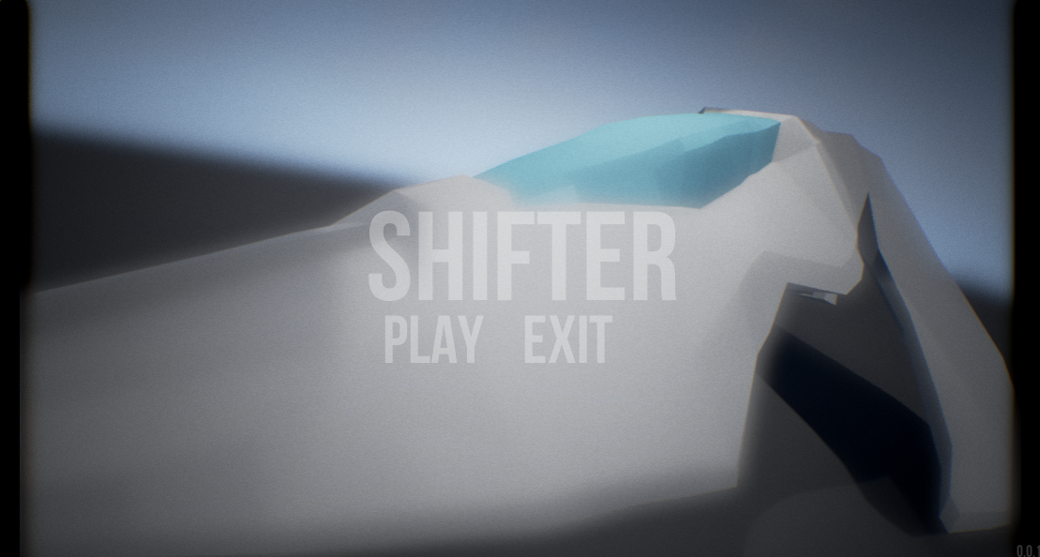
Figure 10.1: main menu
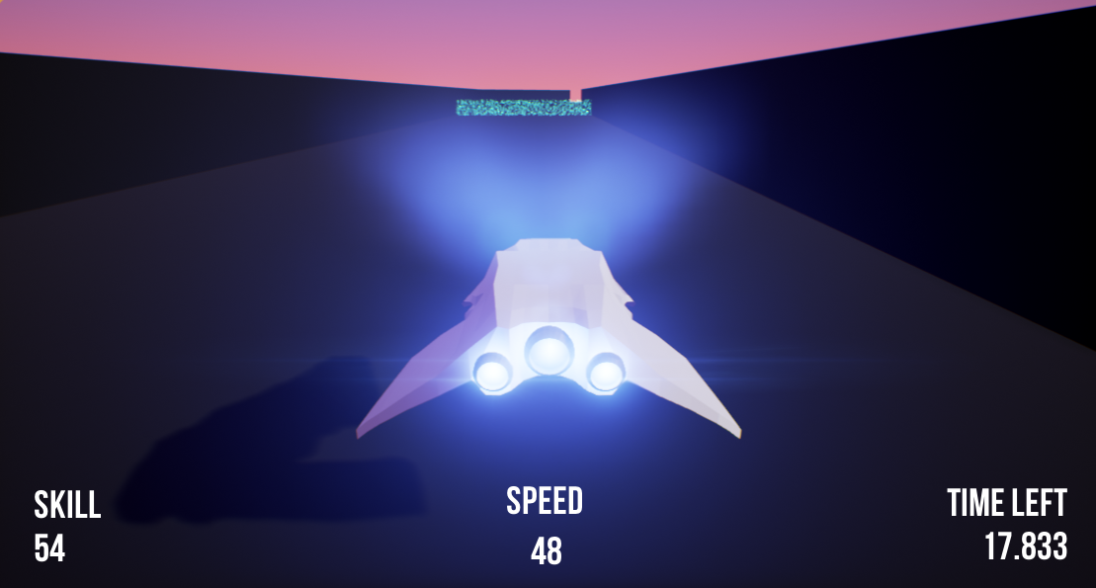
Figure 10.2: Starting position

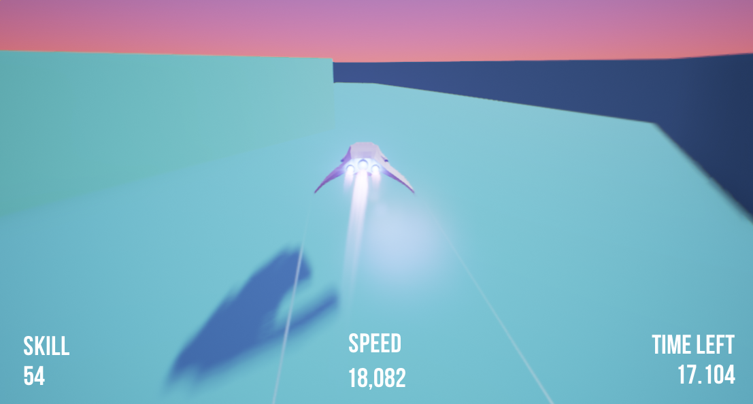
Figure 10.3: Player driving at high speed

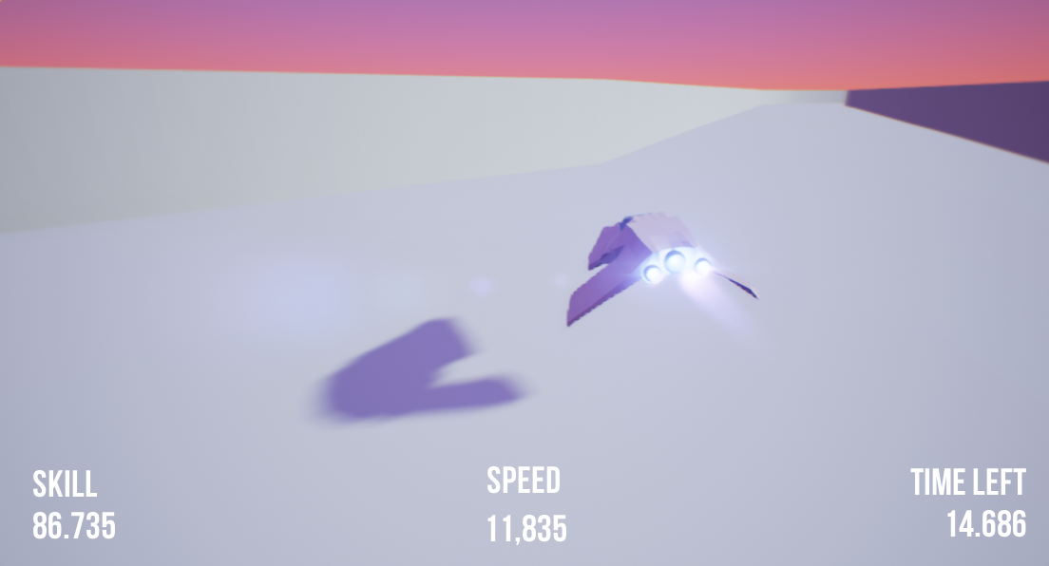
Figure 10.4: Track colour change during a strong player tester attempt

Gantt Chart
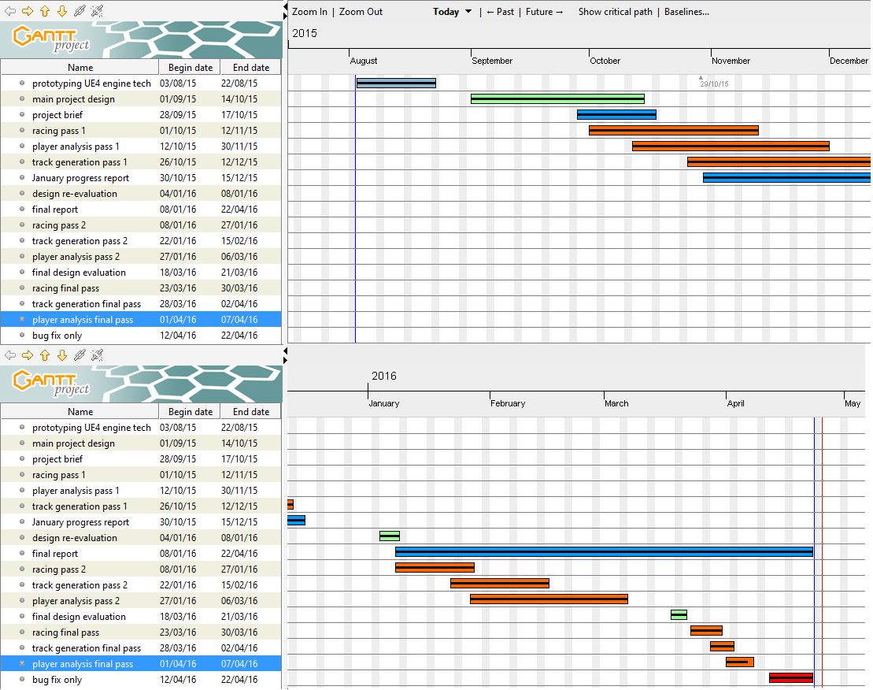
Figure 10.5: Gantt chart of project

